ISO 27001

This is extracted from [here](https://www.youtube.com/playlist?list=PL0hT6hgexlYys_9UWhal1kr9Gkz0ms0sM):

# INTRODUCTION

In ISO27001 we have 10 clauses out of which 4 – 10 are mandatory for every business. These are called Shall, also there are annexures which talk about detail controls in an organization.

So 10 Clauses (Shall), 93 controls (annexures) distributed into 4 groups:

* + Organizational controls (37)
  + People controls (8)
  + Physical controls (14)
  + Technological controls (34)

Clauses are like components that you should have and annexures are just tools that provide you like for e.g. for a house secure door, safety are components but tools like alarm bells and fire extinguishers are controls.

Certification of 2 types individual, in turn into Auditor (audit the standard) and Implementor (implements the standard), and organization

# Basic terms

Documents (written policy), Specification (complexity of document like char count) and Record.

Document contains any information store in any medium (instruction, policy, procedure, general information), Specification a subset of document that layouts the requirements and what needs to be done, Record is a subset of document that captures that something is done (like training sessions or etc.)

# CASE STUDY

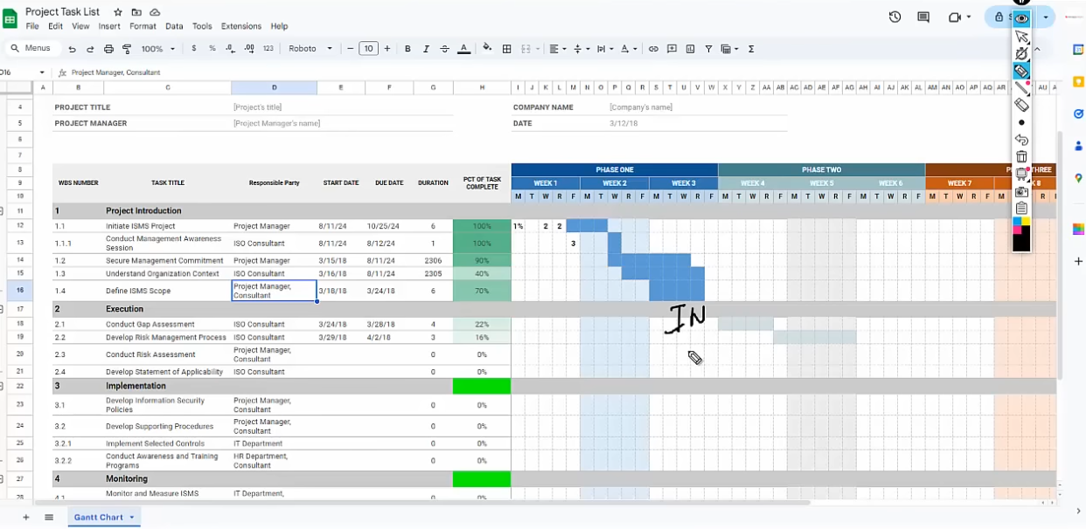

See the tasks scoping must be done before gap assessment.

## WEEK 1-2: Initiation and Planning

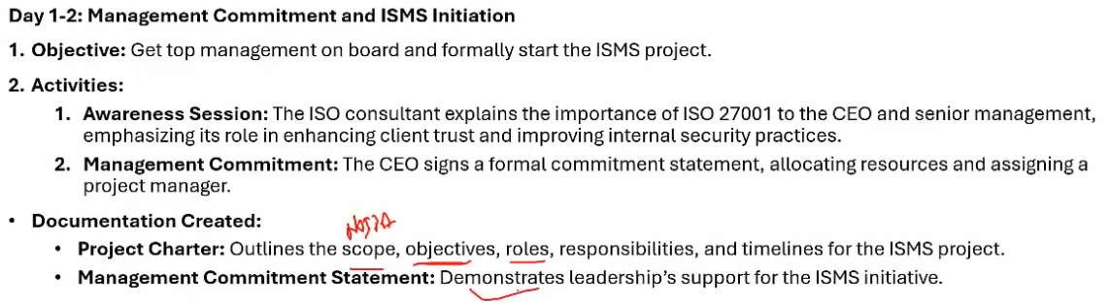

Scope is the location, objective achieving ISO27001, role IT dept can lead the project and whatever. This is the project charter not ISMS charter.

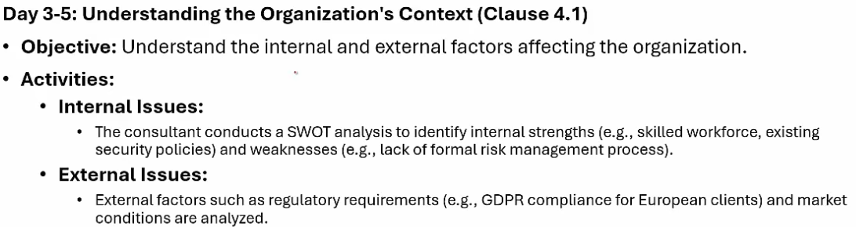

Examine artifacts, interview and then test (EIT) simple principle to follow

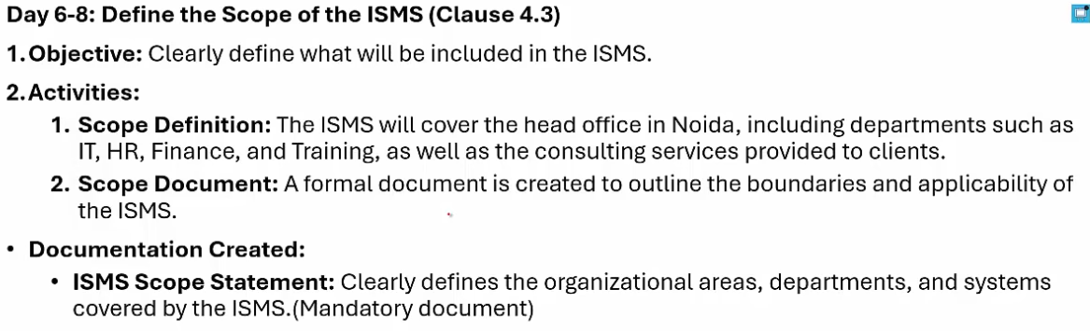

Any department that is not part of information security will not be added to scope

## Week 3: Gap Assessment and Risk Management Planning

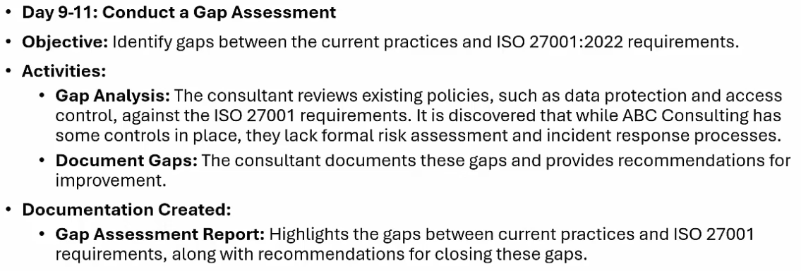

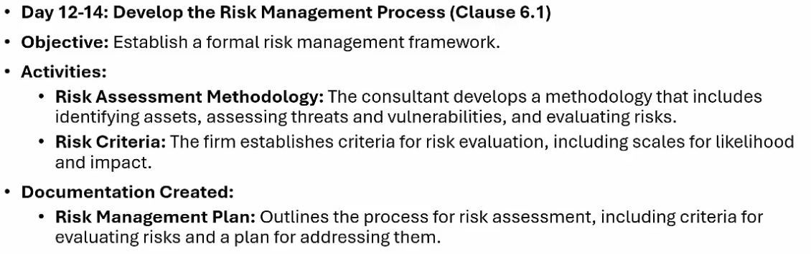

Types of risk assessment:

Process based RA (e.g. loss of proprietary material or disruption of online session treatment is strong access control etc. for big and complex companies), scenarios based (phishing sol. Is awareness training for big companies), Assets based (for small companies).

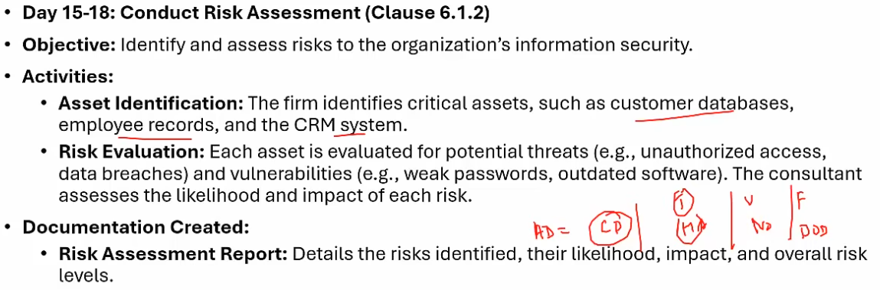

IF we want to remove a risk then proper justification should be there for e.g. one of the control says lock access physically to servers but since we are uploading all data to cloud then there is no such need for this control. 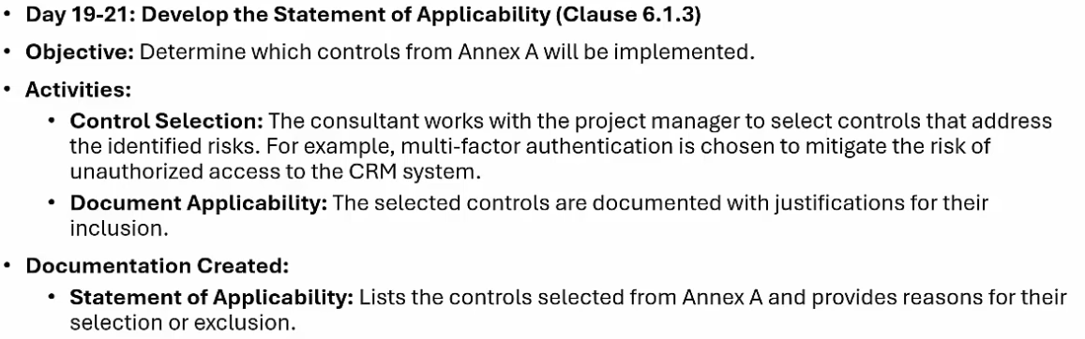

## Week 6-7: Develop policies and procedures

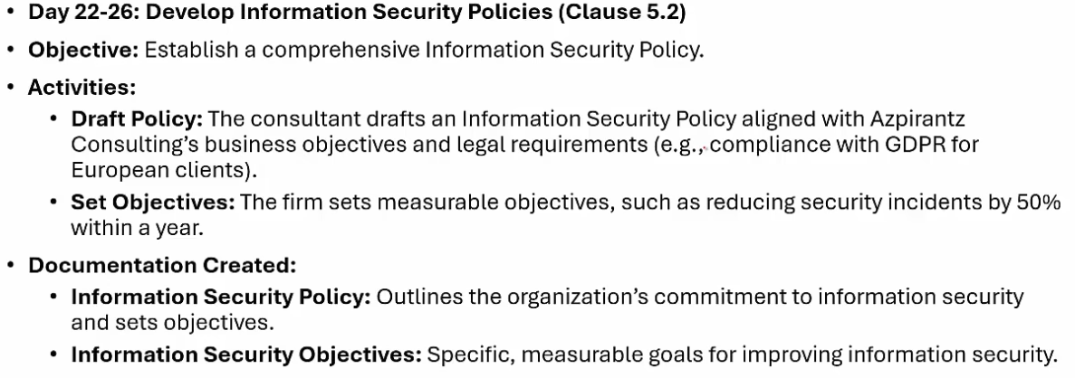

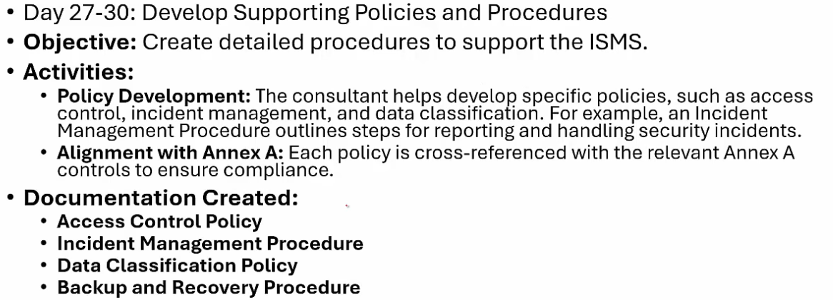

## Week 8-9: Implementation of control and awareness

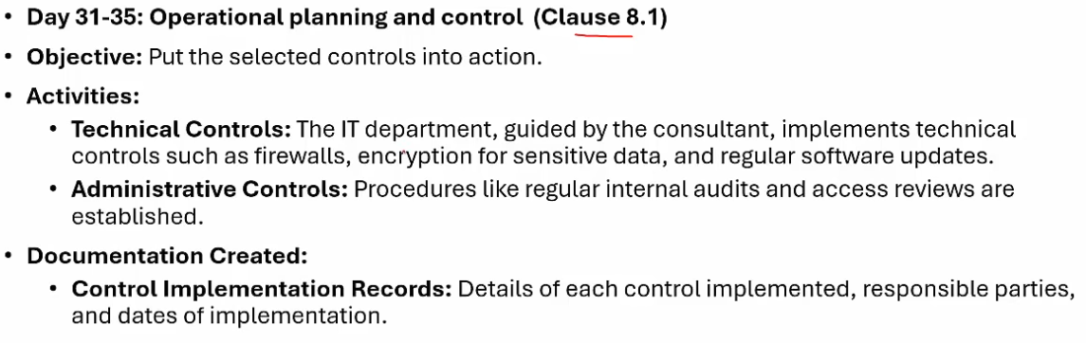

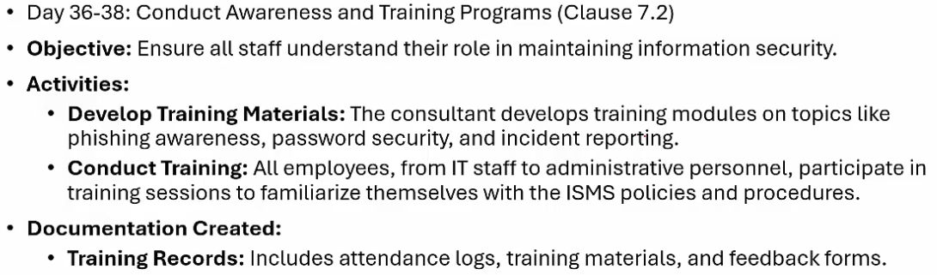

## Week 10: monitor, review and internal audit

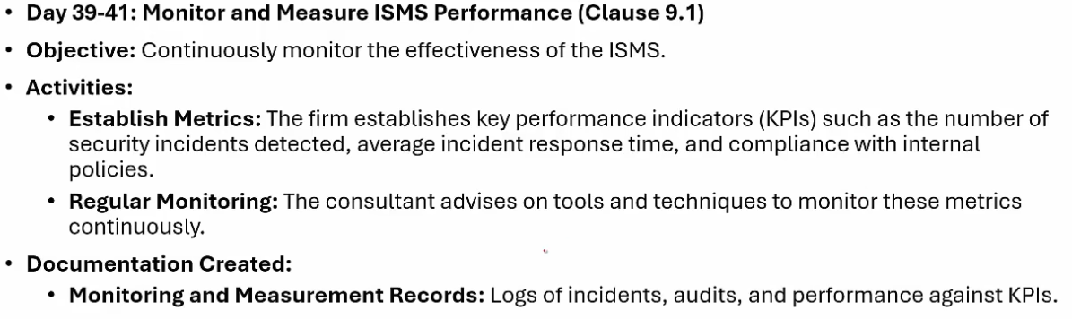

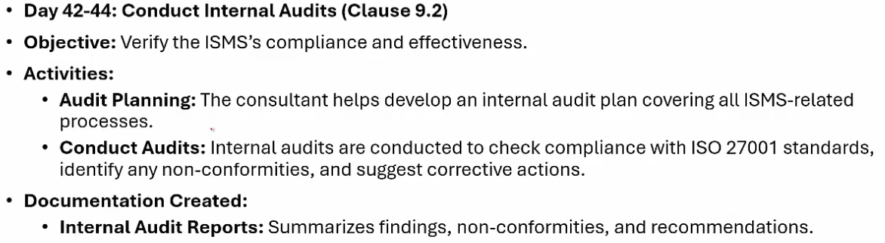

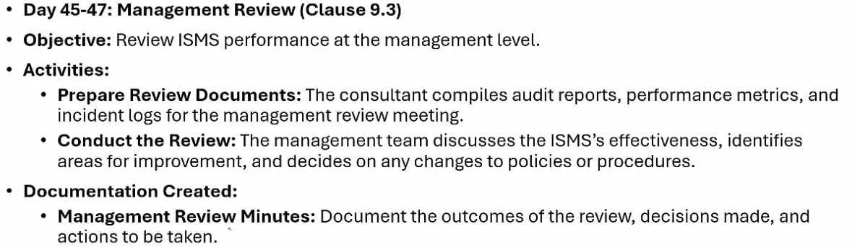

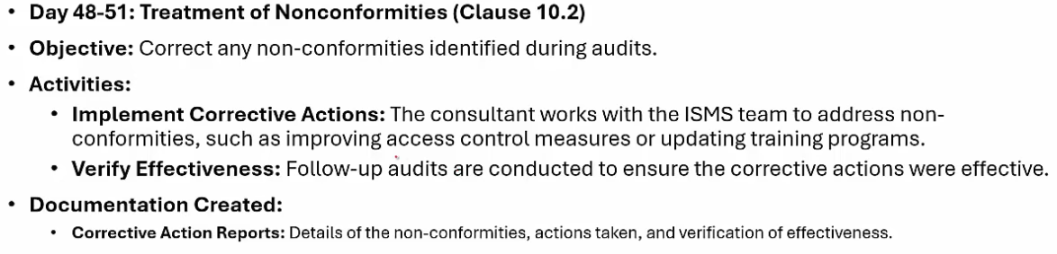

## Week 11-12: Continuous Improvement and Certification Preparation

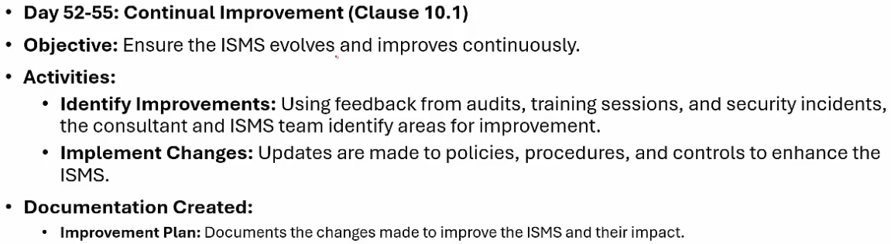

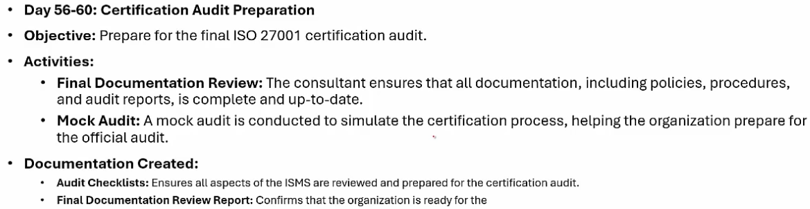

## Mandatory Documents for ISO

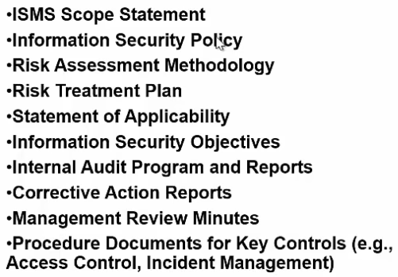

# Project Initiation Document

Scoping three categories: Information systems, physical, organization.

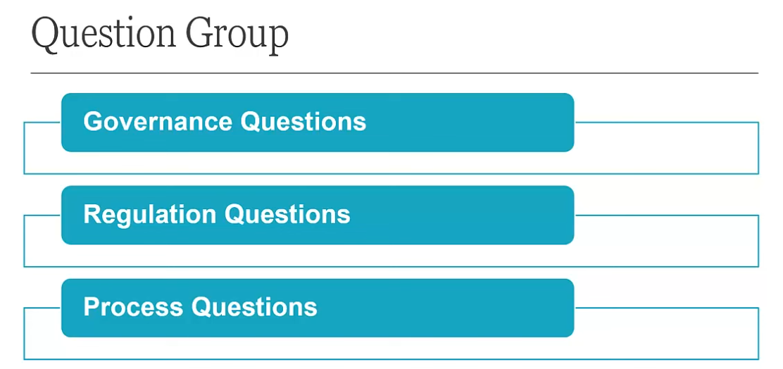

Governance q example; do you have a policy, regulation where do you operate,

## Questionnaire

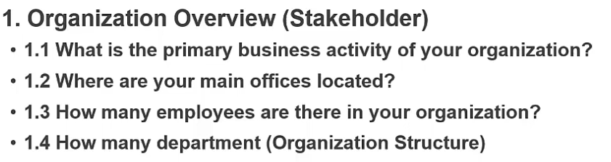

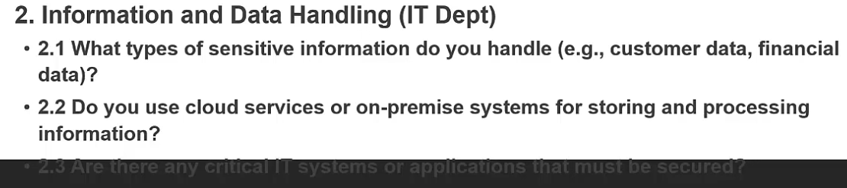

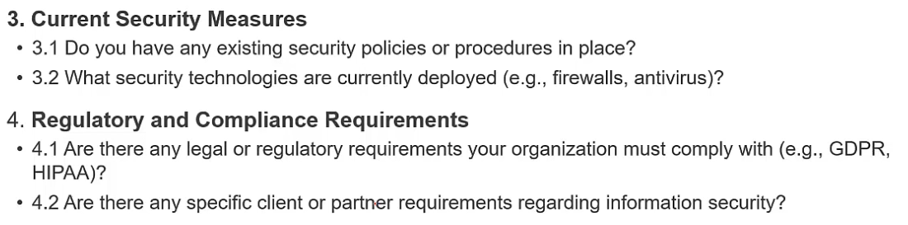

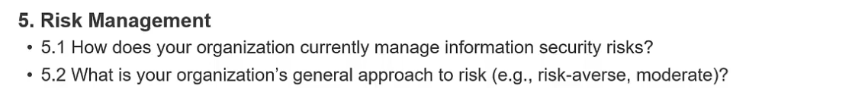

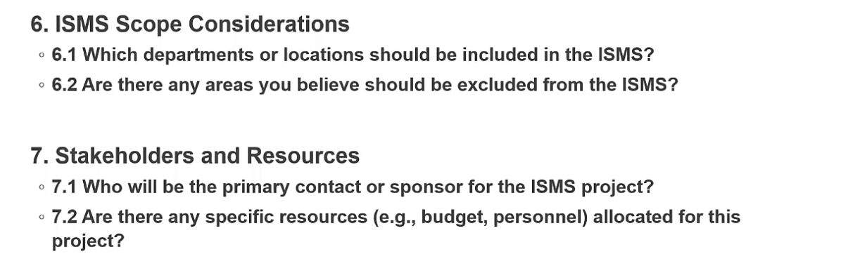

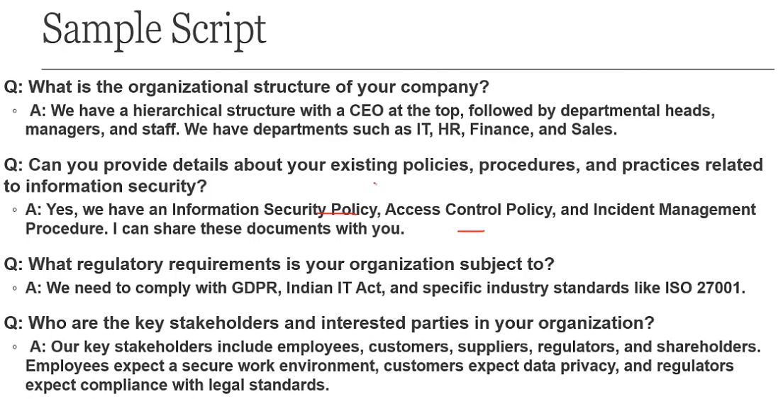

ISMS project initiation Document is first document.

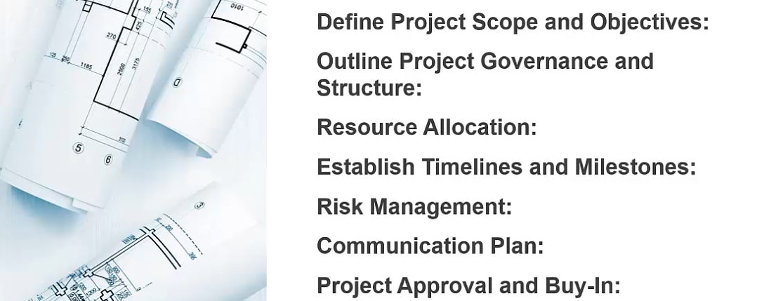

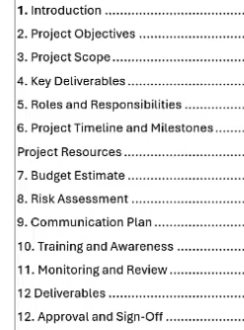

Project scope we will get after getting answers of those questionnaires 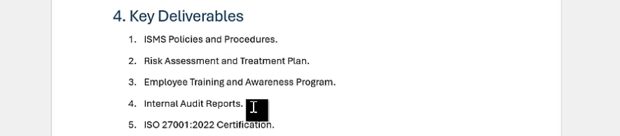

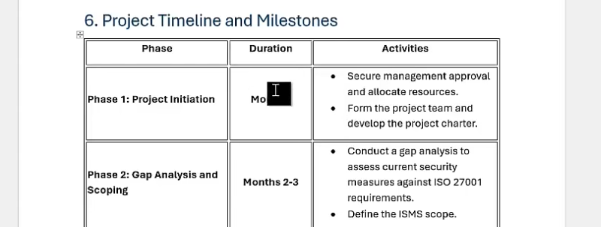

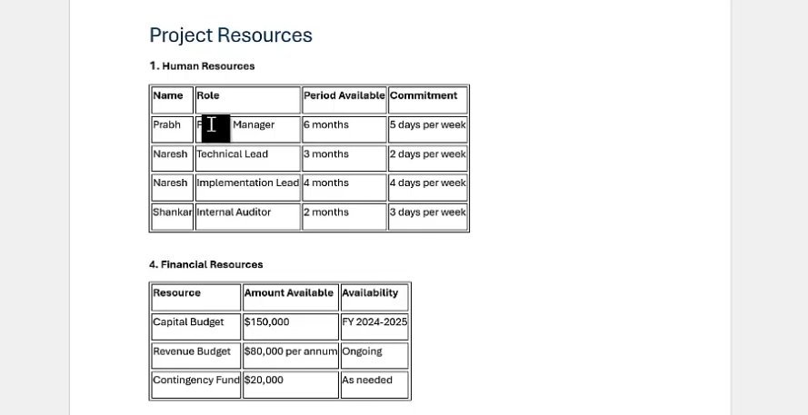

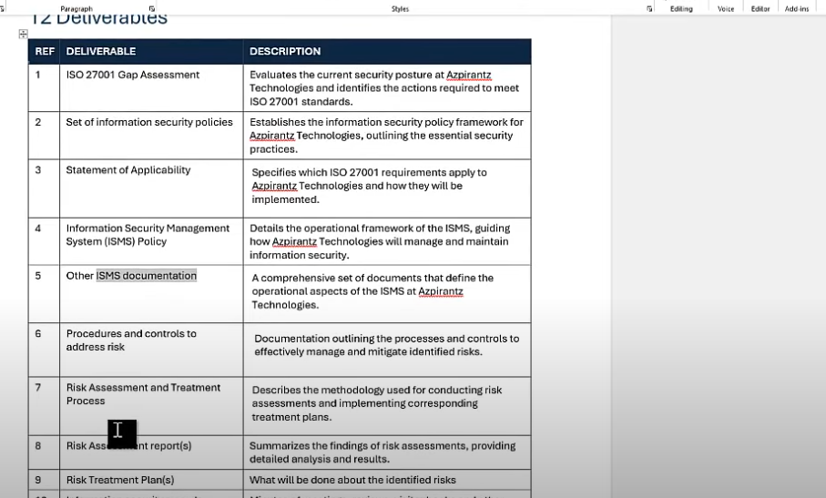



If at any point in time the project is going out of cost or out of timeline then the PID will be updated with version and then will be signed again. 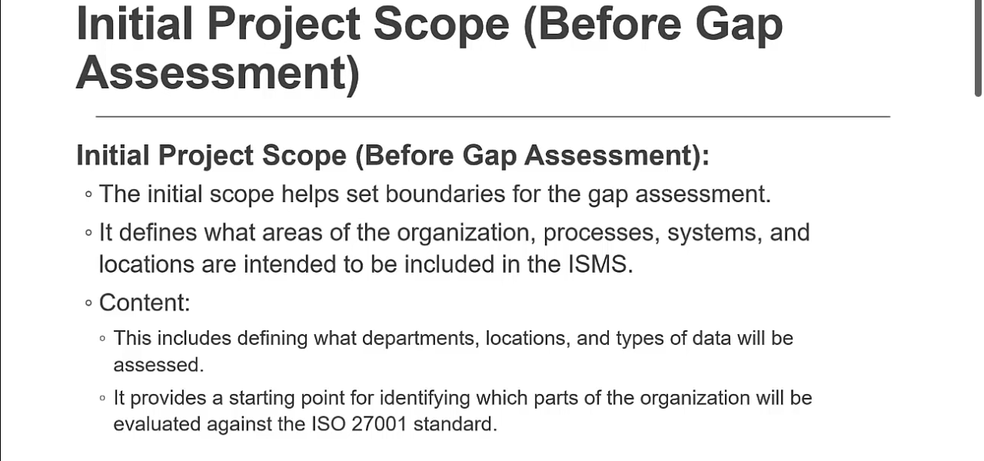

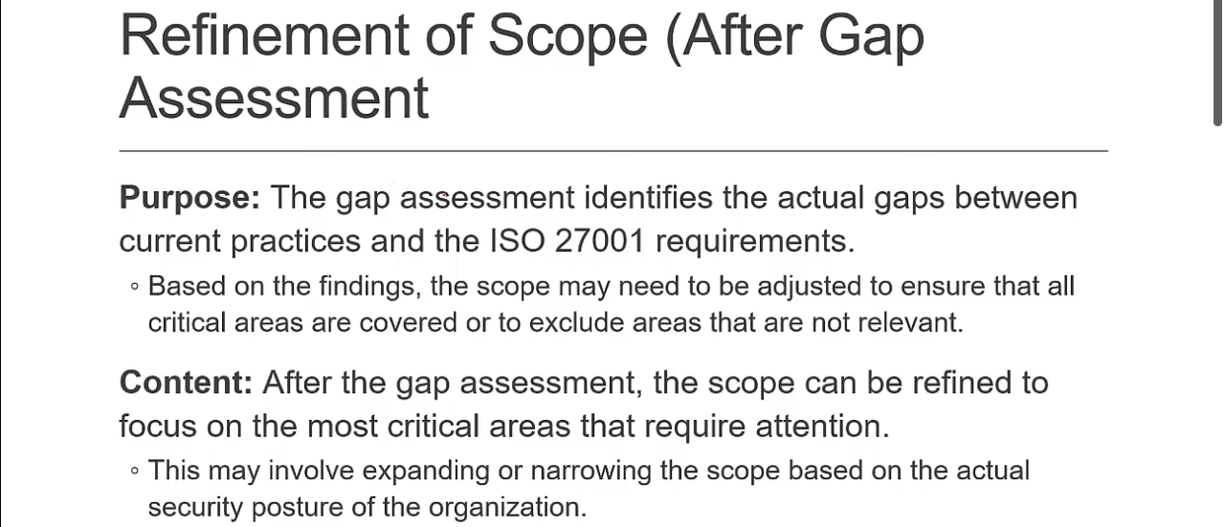

Best practice:

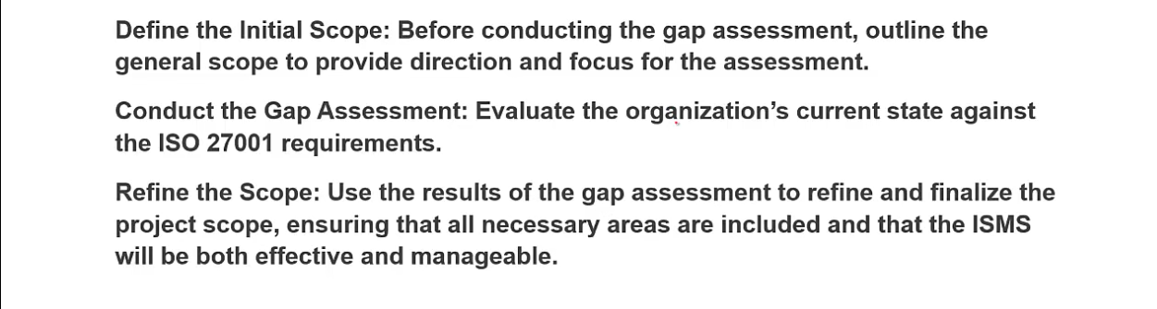

PID is usually sent out after Business case wchich is a presentation or first meeting.

# ISMS Context Document: ISMS Clause 4

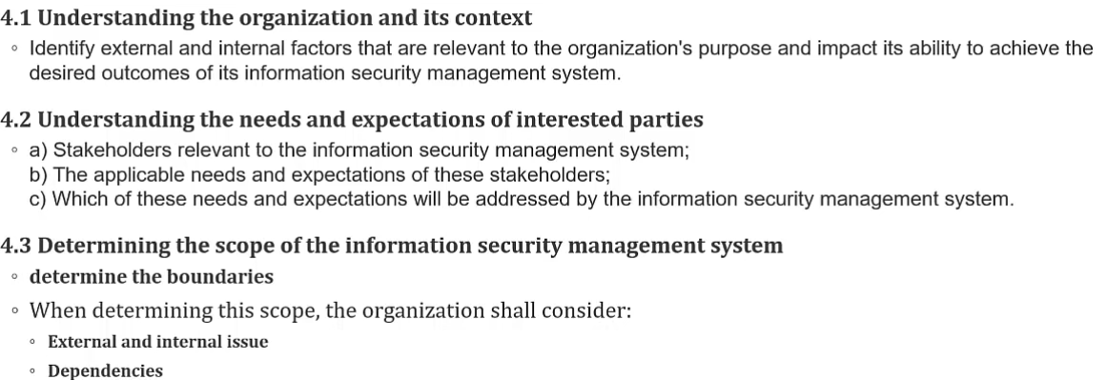

Before identifying issue we need to identify scope.

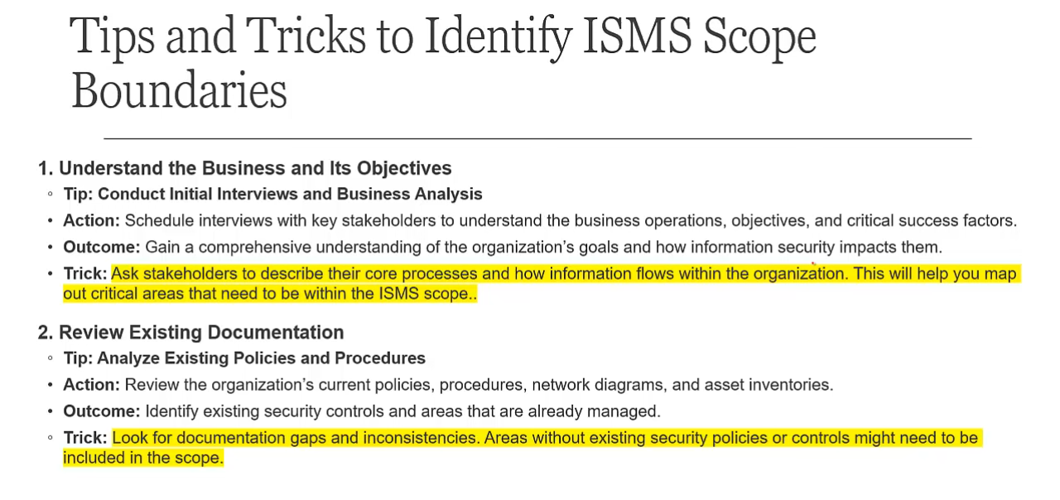

In point 2 review existing policies and controls if exist. For point 3 example we have a datacenter, CRM, CRM is where hosted inside or external, workstations for assets etc. First identify business then its assets. Only departments holding PI data will be in scope like marketing holds data for analysis will be in scope whereas facilitation dept. will not be in scope.

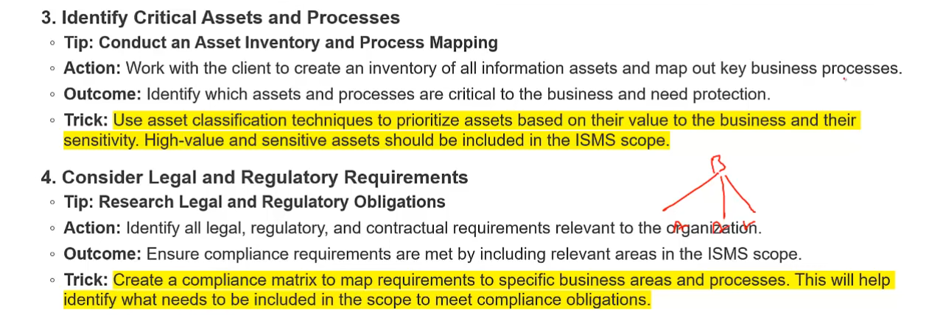

We can also create a compliance metric (internal for self) which tells you the legal compliance against your institution in your operational country.

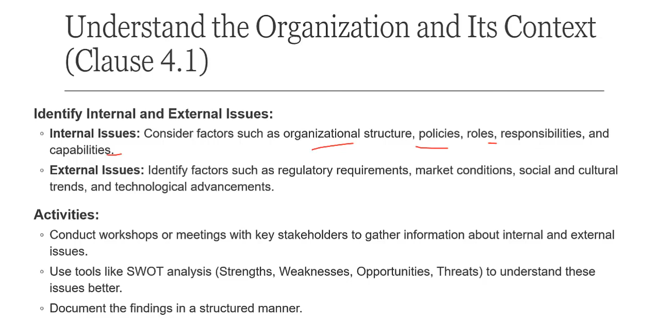

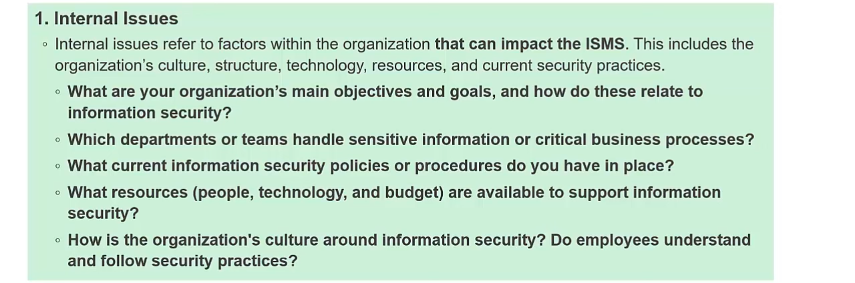

Culture = understanding or people`s view regarding security. 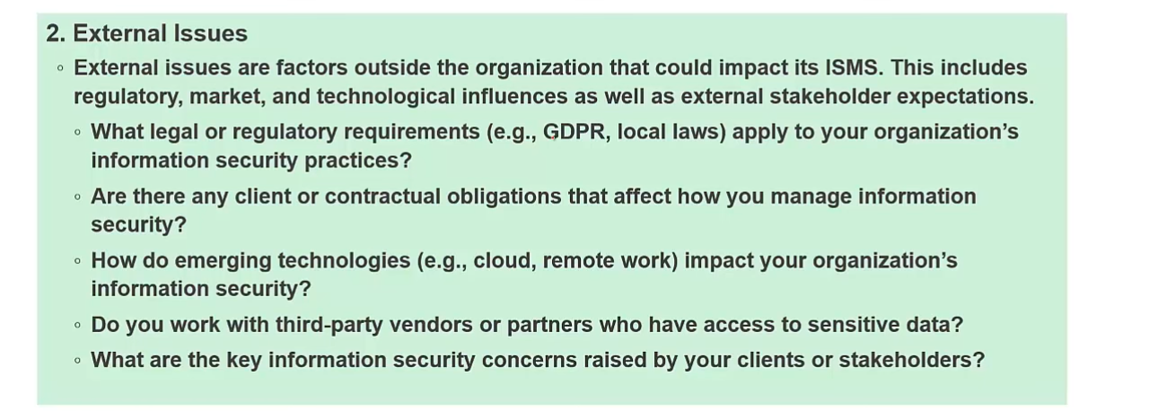

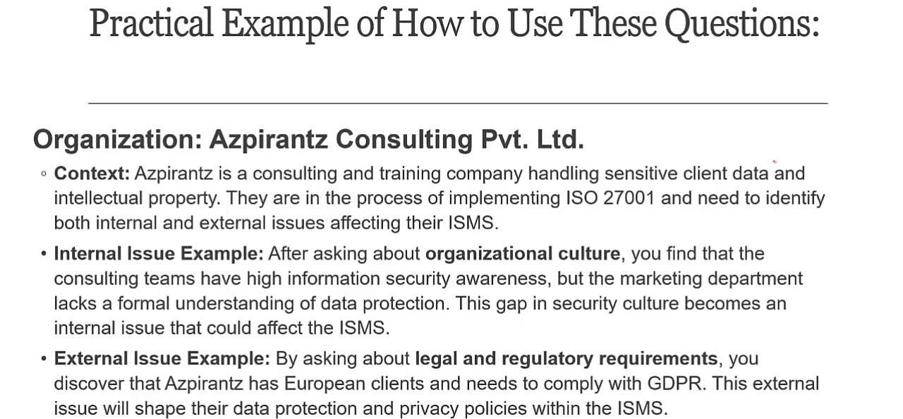

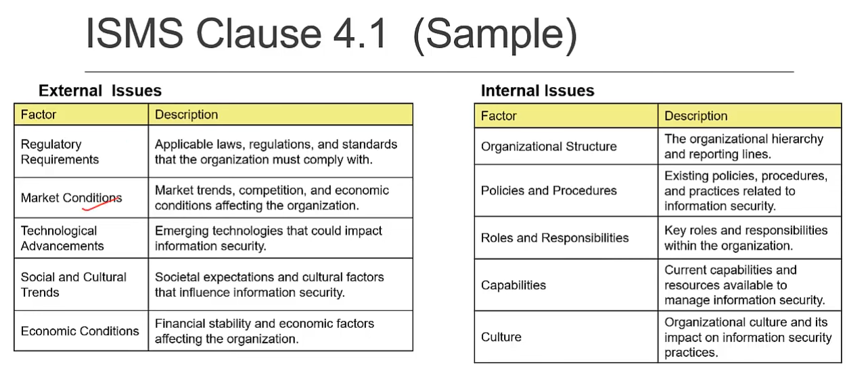

Market conditions and regulatory requirements are always documented. All issues needs to be included.

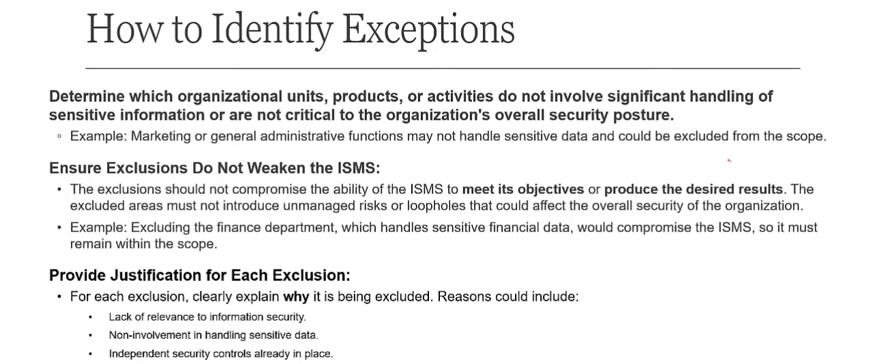

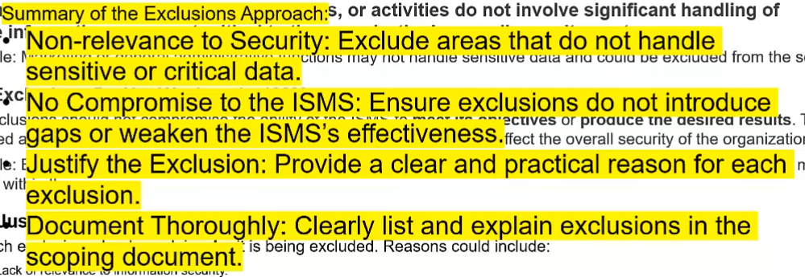

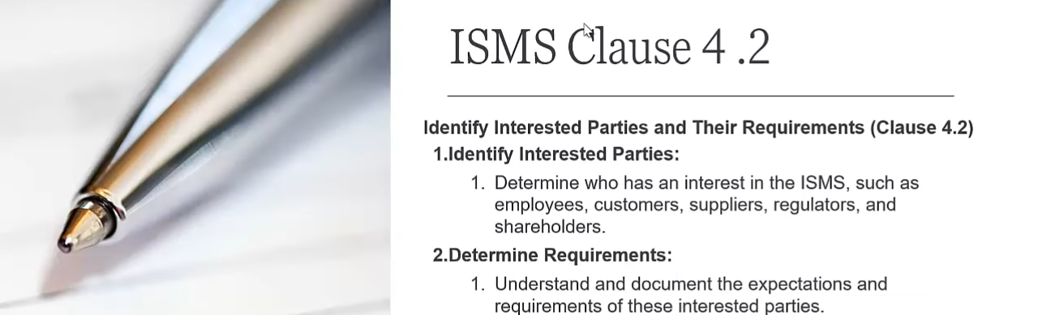

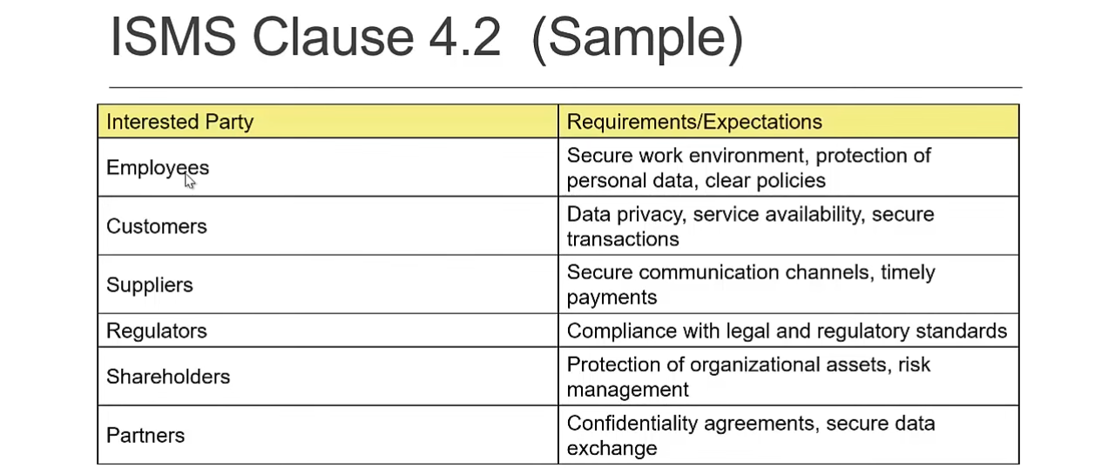

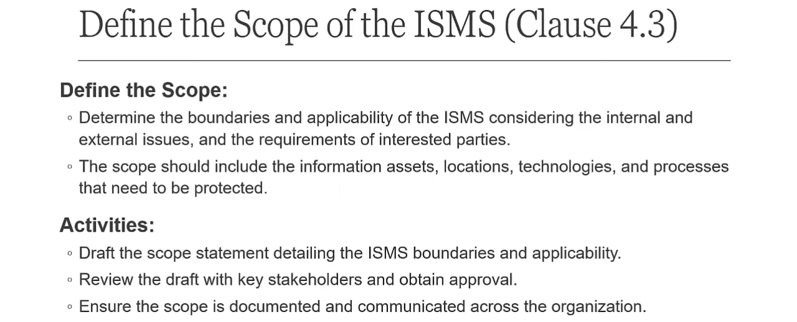

Step1: Define the scope

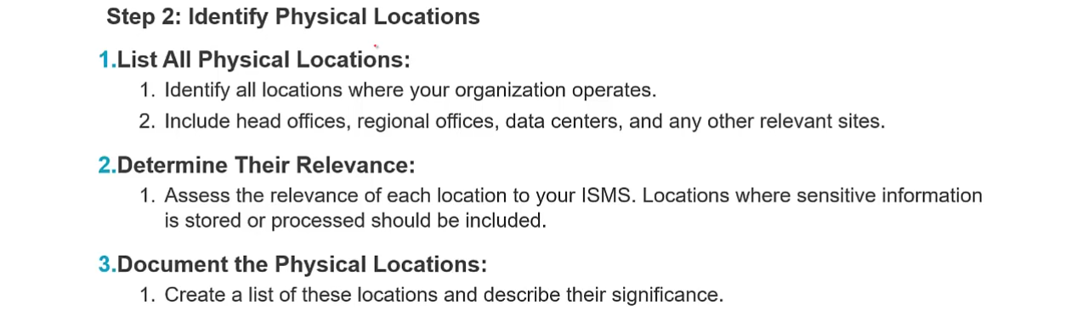

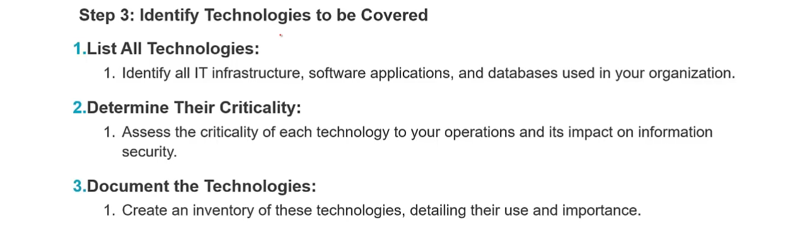

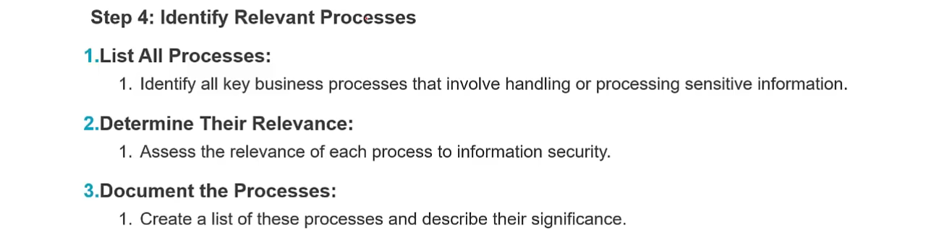

For e.g. finance, HR and training are processes.

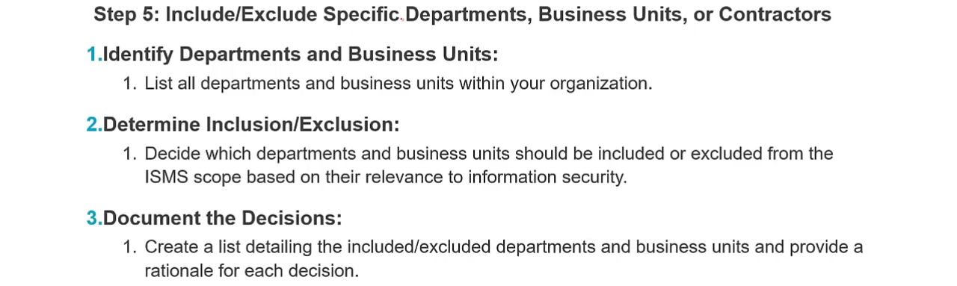

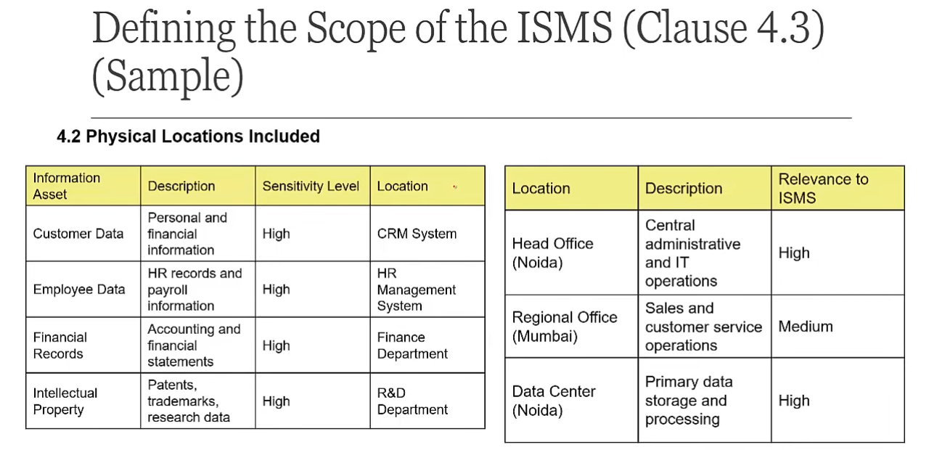

Document review starts at [22:46](https://youtu.be/wL2GSovv4Ok?si=fbOjFkjuTxVtrD7N&t=1366), purpose of ISMS will always remain same

# Conduct Gap Assessment: Clause 4 – 10

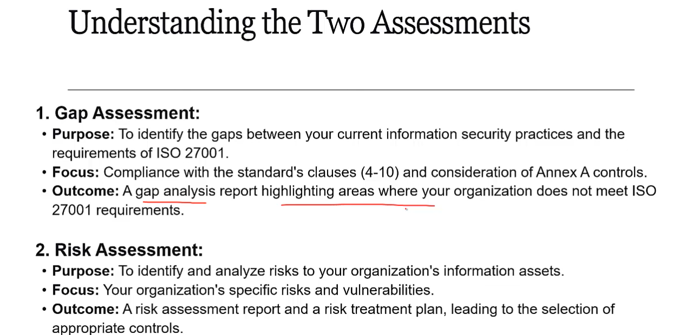

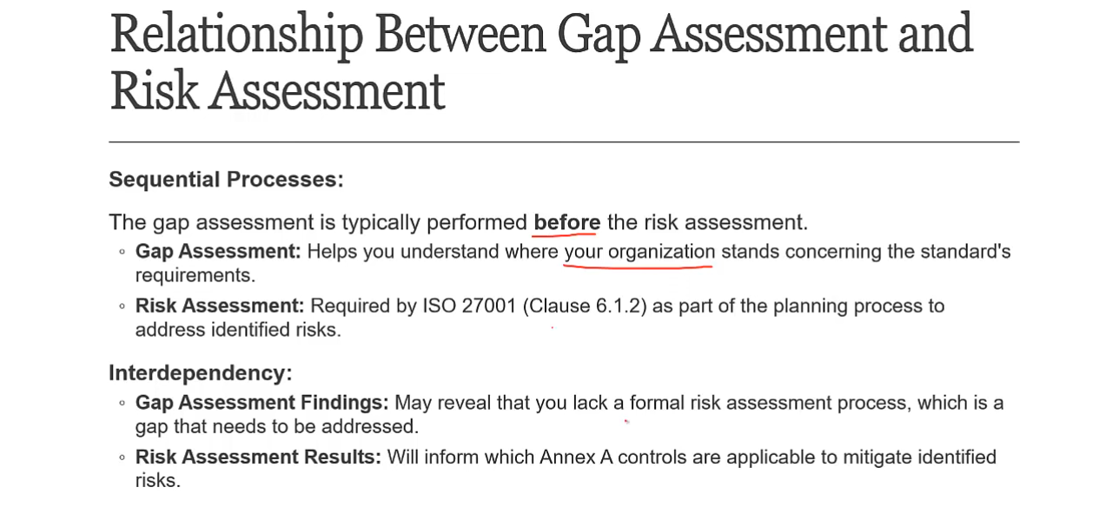

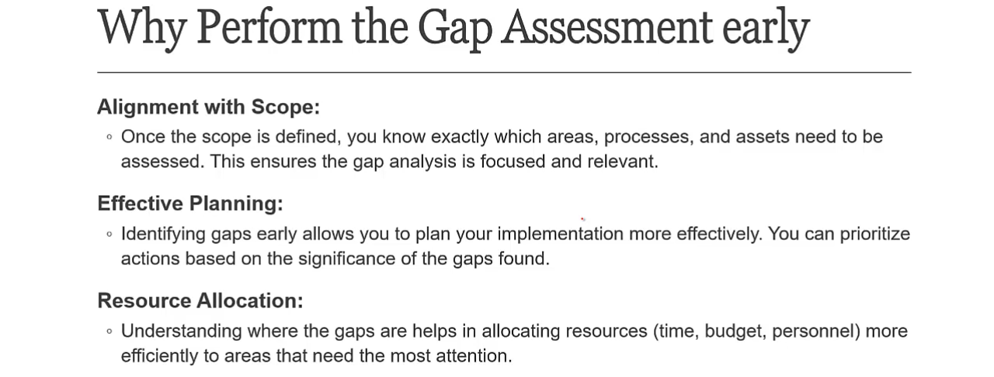

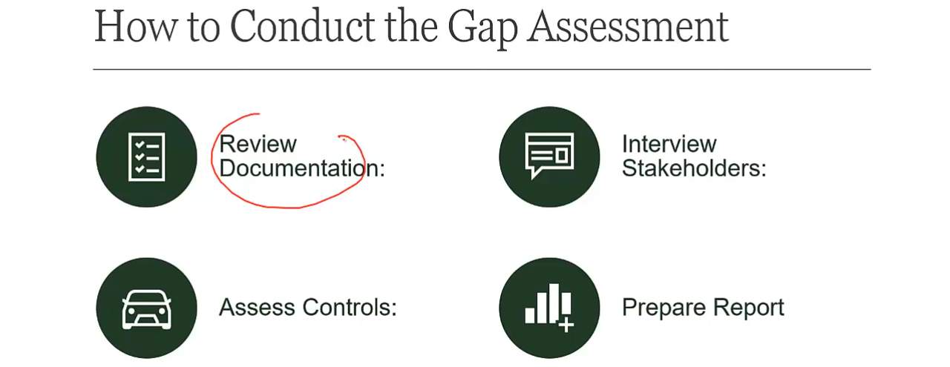

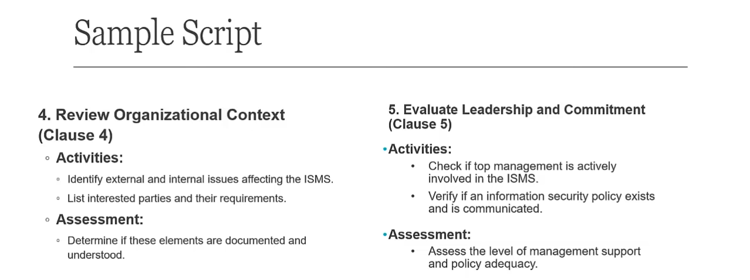

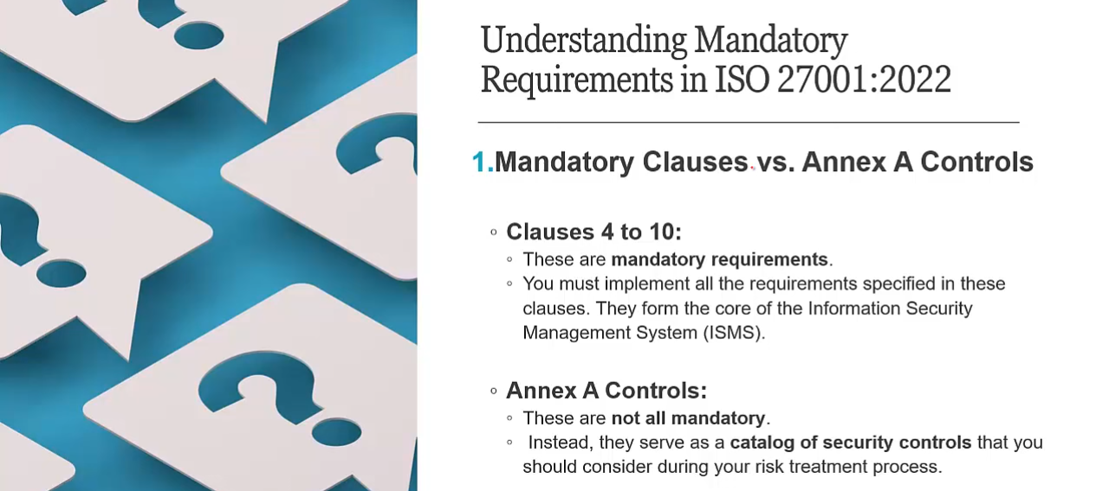

Template starts at [6:43](https://youtu.be/fhSH2uV-jK8?si=xH7QuLWG295TFnAb&t=403):

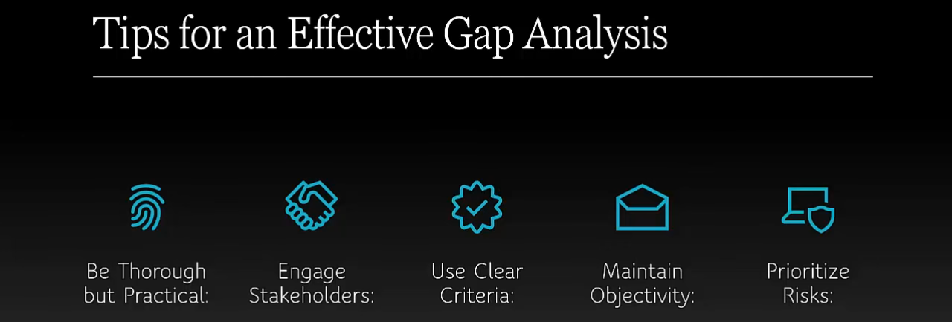

Clear criteria means clear proper statuses: compliant, partial compliant etc.

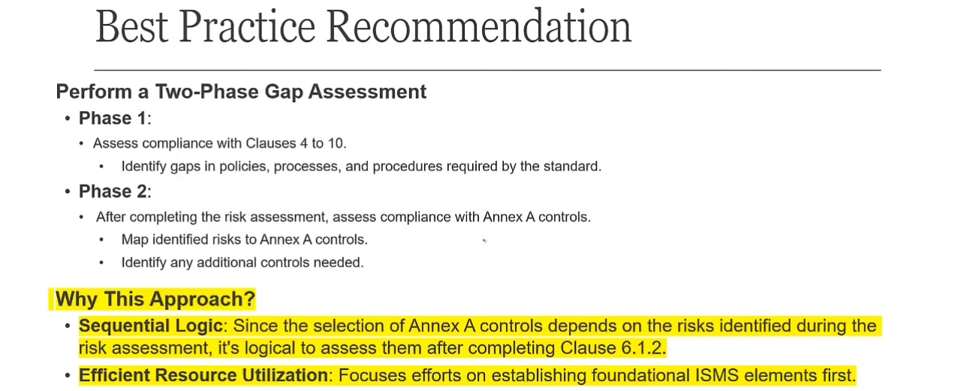

So once youdid the gap assessment second next step is gap analysis report then create a security policy and then dump to risk assessment clause 6

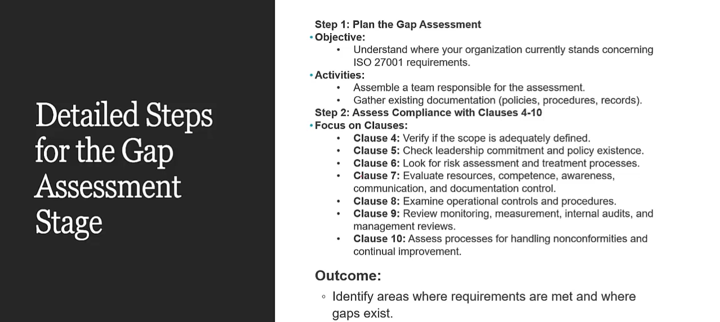

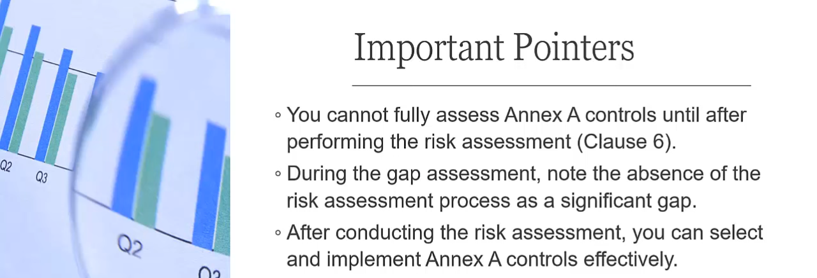

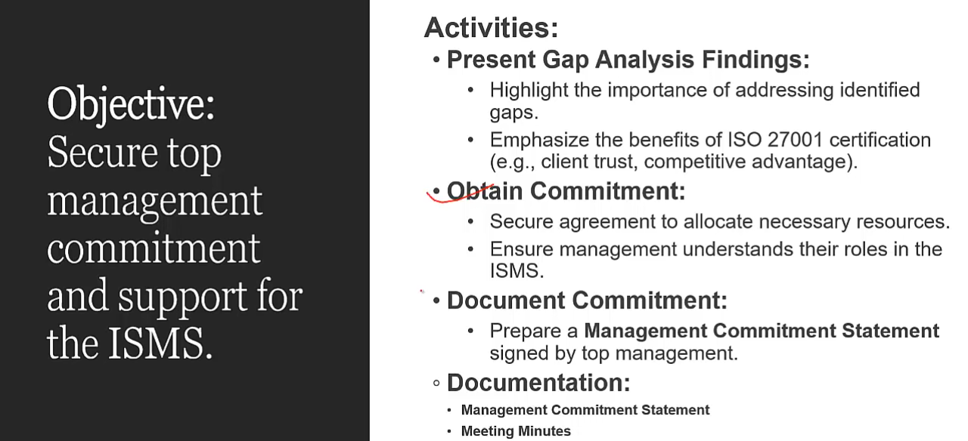

# Security Policy

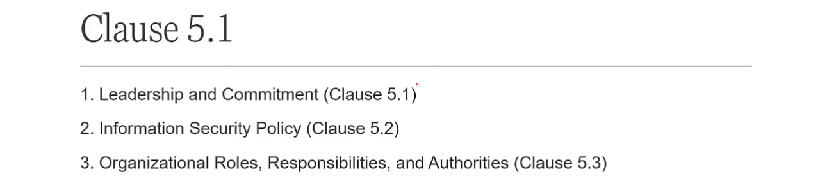

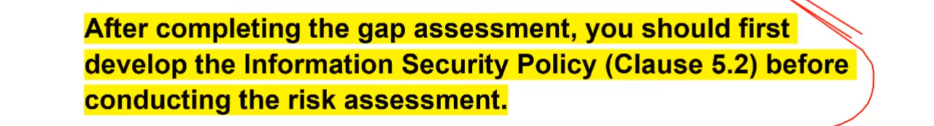

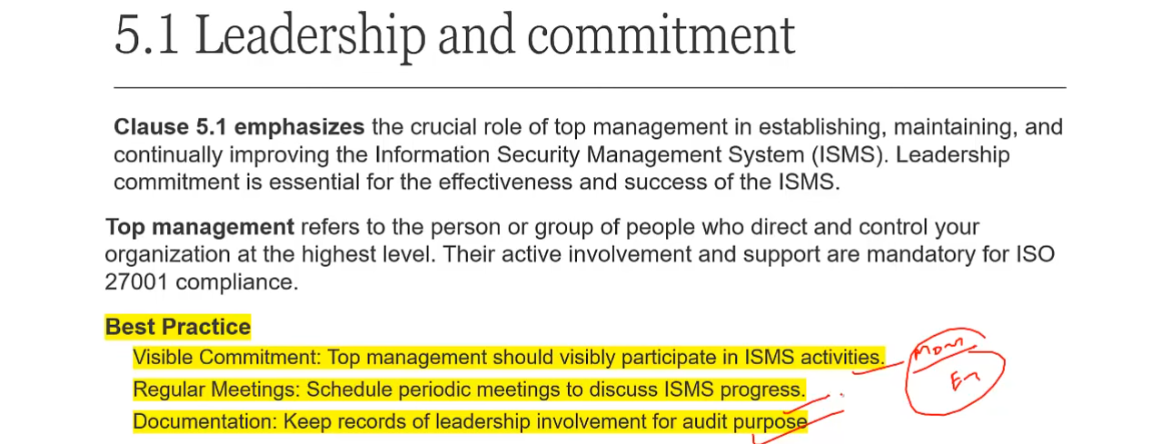

Top management should participate in ISMS activities by Minutes of Meeting, email records etc.

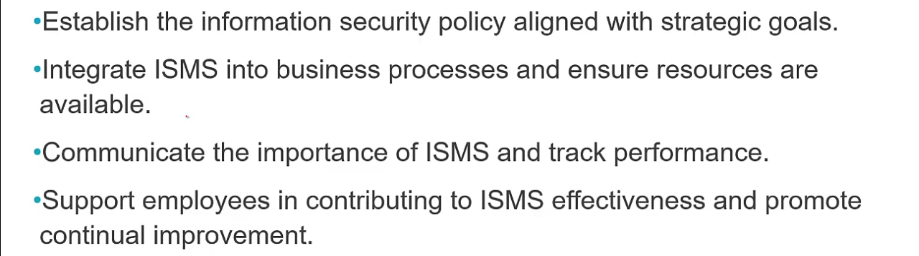

Policy is always strategic in nature

An example of policy every system must be protected with a policy. Why policy business requirement, legal requirement, senior management interpret the requirements (create a policy) and operational staff (people, process and technology) they comply with that. Policy is the foundation of company its like a law. Every policy must form a uniform standard and each standard implements a procedure.

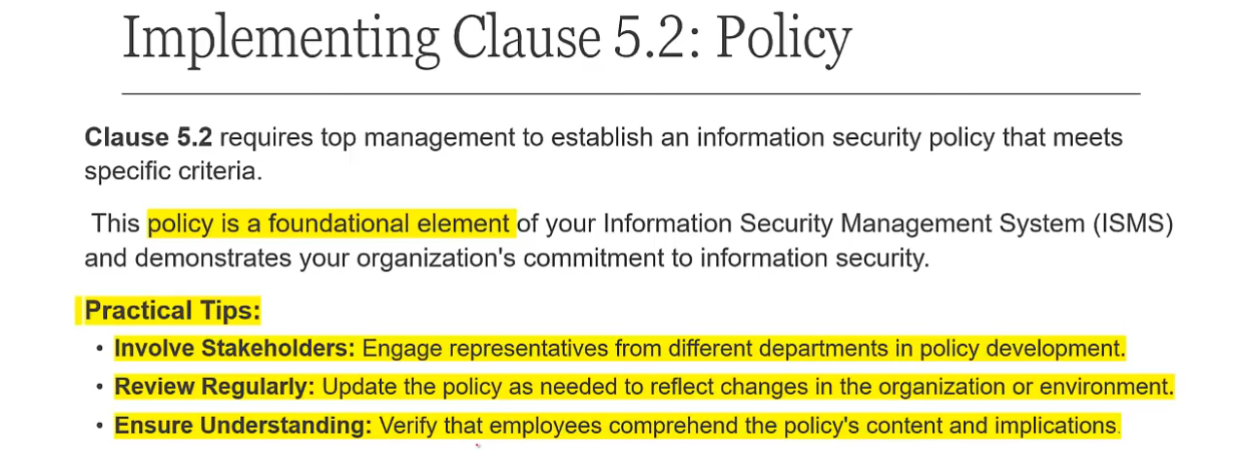

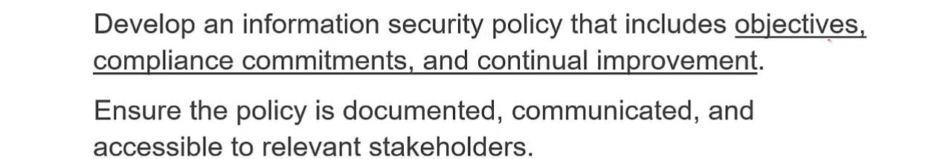

Policy template starts at [8:19](https://youtu.be/BmHfmNj1JMU?si=ez5d7kU3qNGcUHD5&t=499), for policy in table of contents first 3 and last 2 are important the rest can be optional.

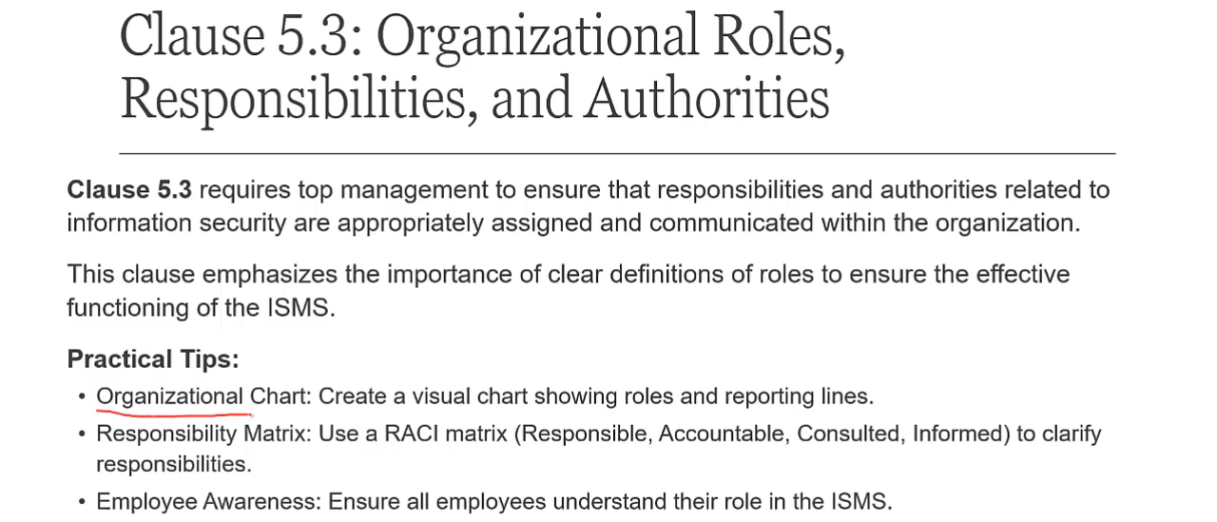

RACI is not mandatory. Clause 5.1 is used to establish 5.2 and 5.3.

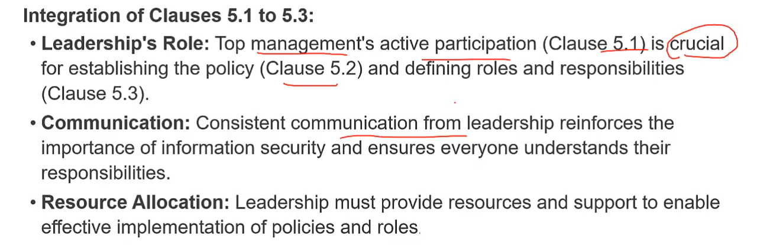

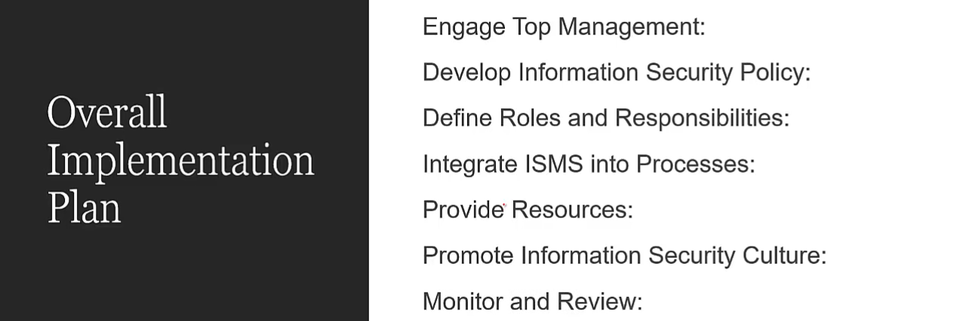

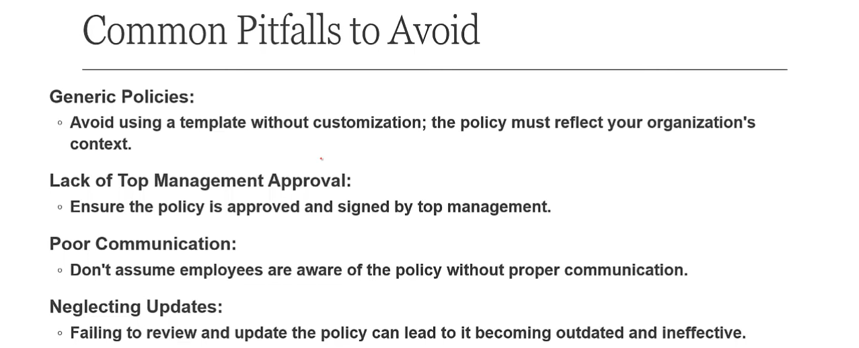

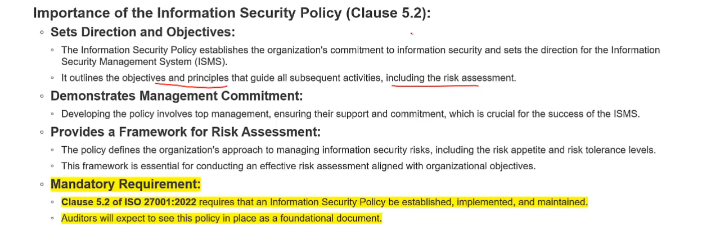

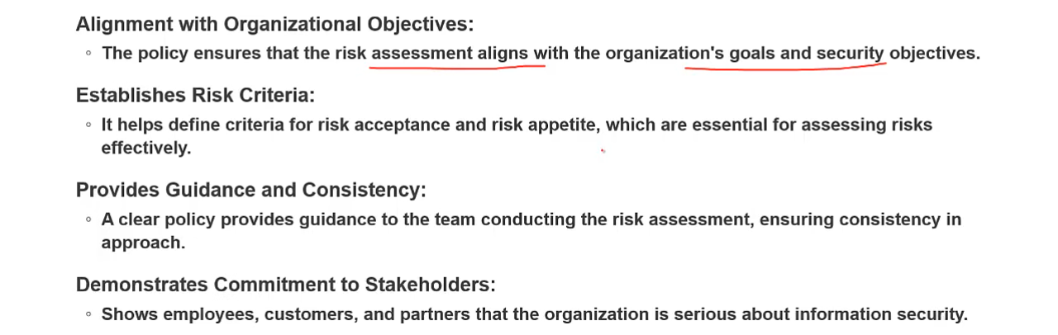

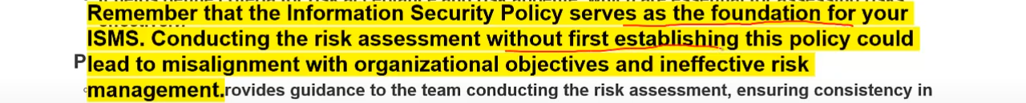

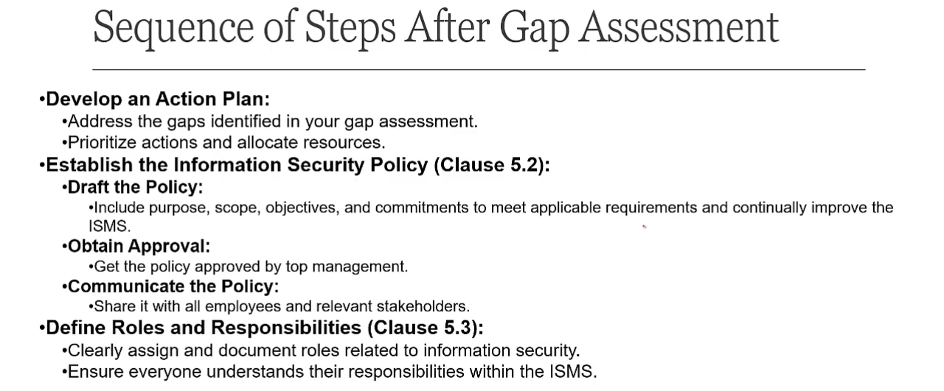

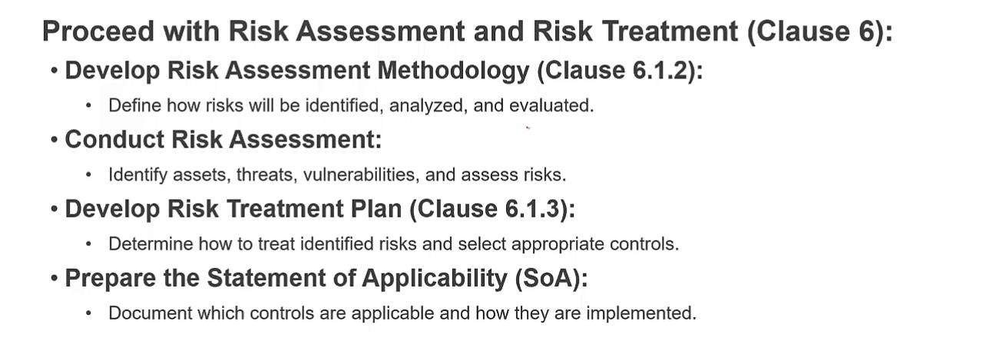

Organizational Roles and Responsibilities Charter template starts at [20:09](https://youtu.be/BmHfmNj1JMU?si=NkO4b80r9SMM9lI2&t=1209),

For clause 5 you need 4 to 5 documents, ISMS manual, Roles and Responsibilities Charter, Executive support letter (optional), IS Policy, MOM.

# RISK ASSESSMENT and TREATMENT

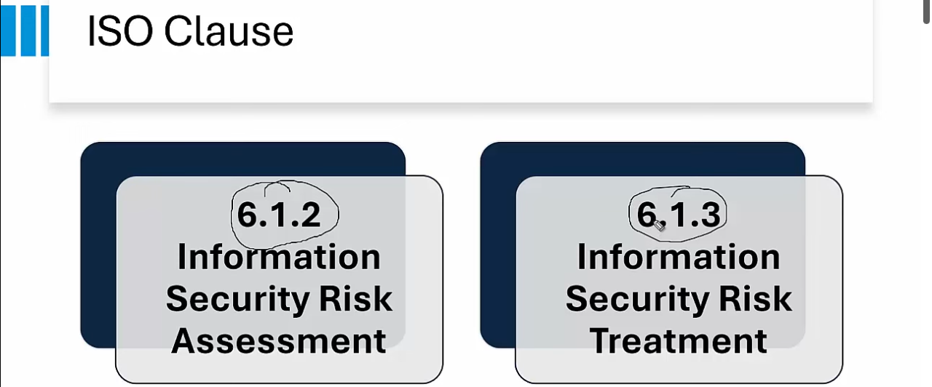

Risk Assessment Terminologies: Threat (hacker doing hacking or action is threat), Vulnerabilities (weakness that results in threat), Likelihood, Impact. Formula for Risk = Likelihood times Impact.

Risk Management Strategy:

* Risk Identification
  + Asset identification
    - Tangible assets
    - Intangible assets
  + Identify threats and vulnerabilities
  + Level of risk calculate
* Risk analysis (calculate level of impact)
  + Qualitative
  + quantitative
* Risk Evaluation; mapping of following 2
  + Risk Appetite
  + Risk Capacity
* Risk Treatment
  + Accept
  + Transfer
  + Mitigate
  + Avoid

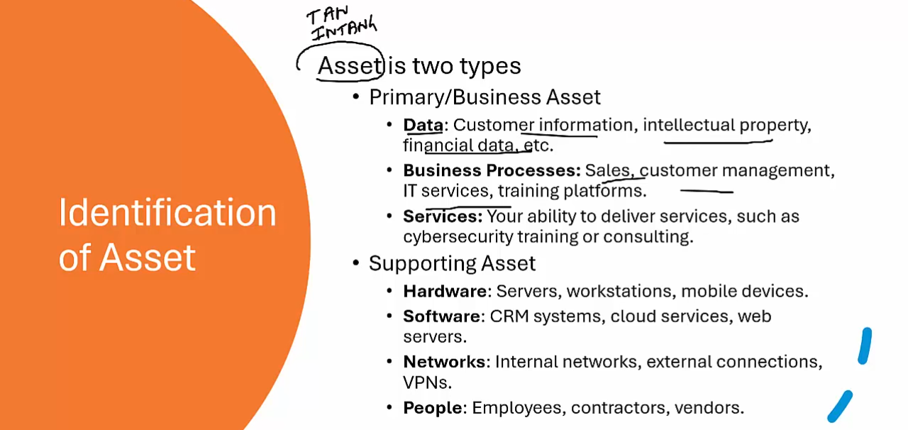

Event based risk assessment in based on intangible stuff like if customer management services is down what will be its impact, in asset based risk assessment e.g. if a particular hardware is down

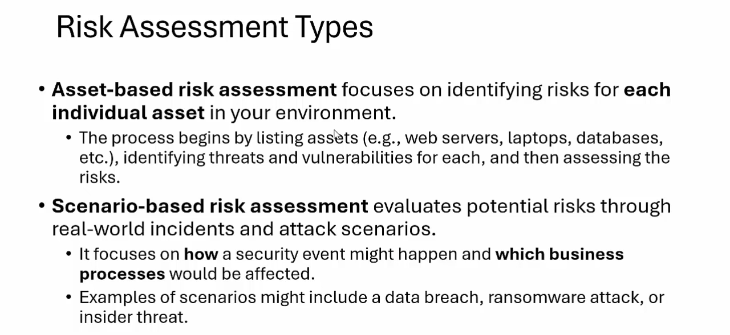

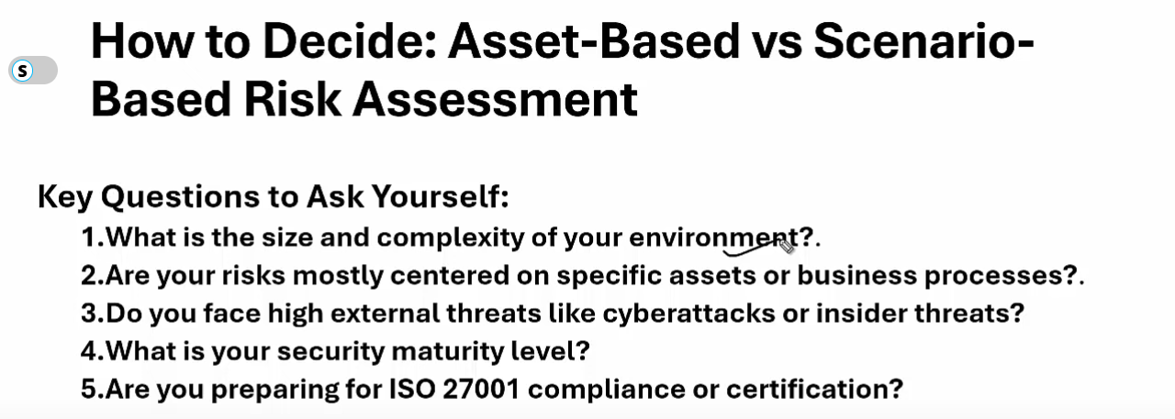

A1. If the organization is small and few assets then we will do asset based.

A2. If your primary goal is to protect a particular asset like web server then go for asset based else if you want to protect business support its process to support continuity of business then scenario based.

A3. If cyber attack then scenario based is best else if more traditional risk like physical risk or downtime risk then asset.

A4. More mature then scenario based.

A5. Asset based is minimum but scenario based combined with asset is best.

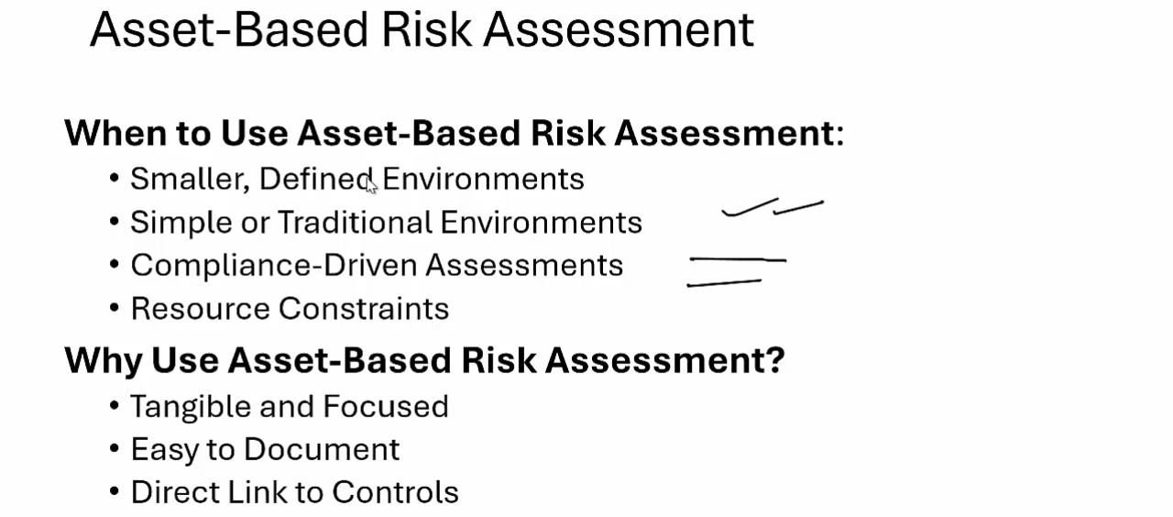

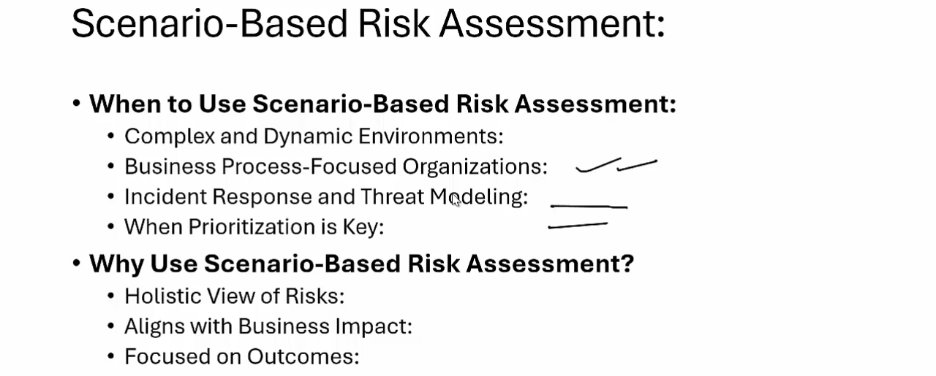

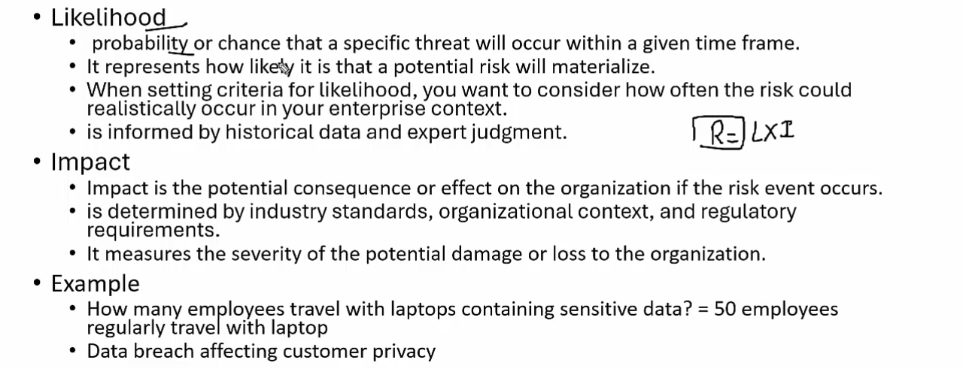

For numbers use past history for estimation. Impact examples are data breach, data loss, potential fines, reputation loss.

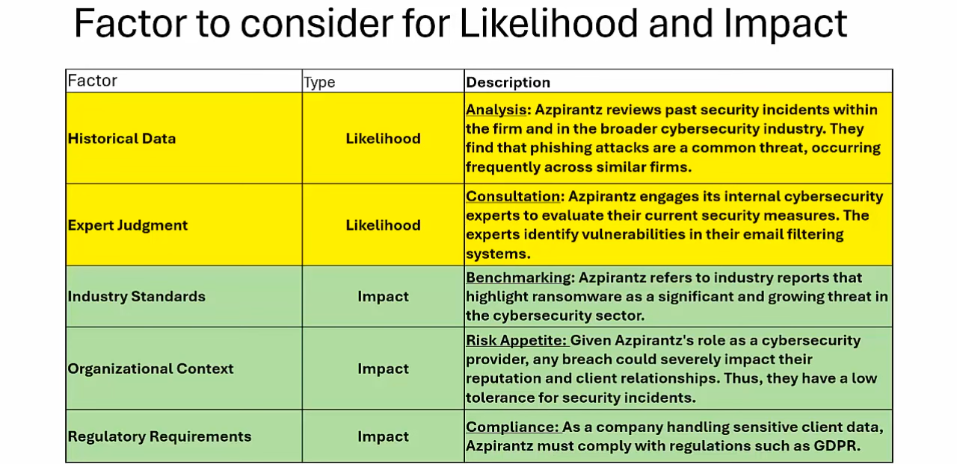

Industry Standard: PI data should be given 5, reputation loss should be treated as 5,

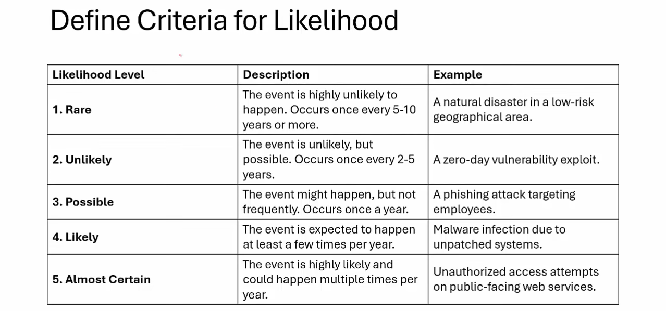

Give a score based on the frequency like: if an attack happens every 2 years then we will give it a score of 4 etc.

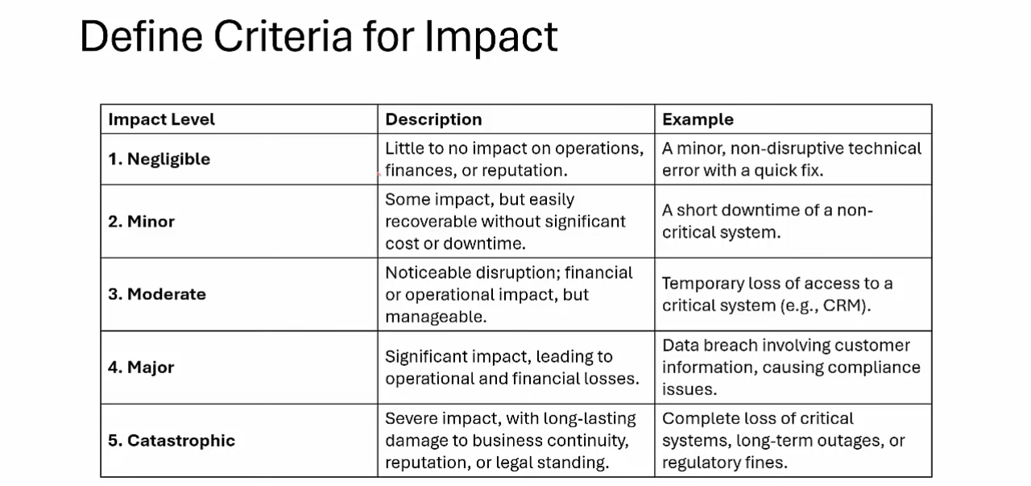

Formulat for impact: organizational disruption, financial loss, reputation damage and legal.

Operational means how important is the system also contains down time impact.

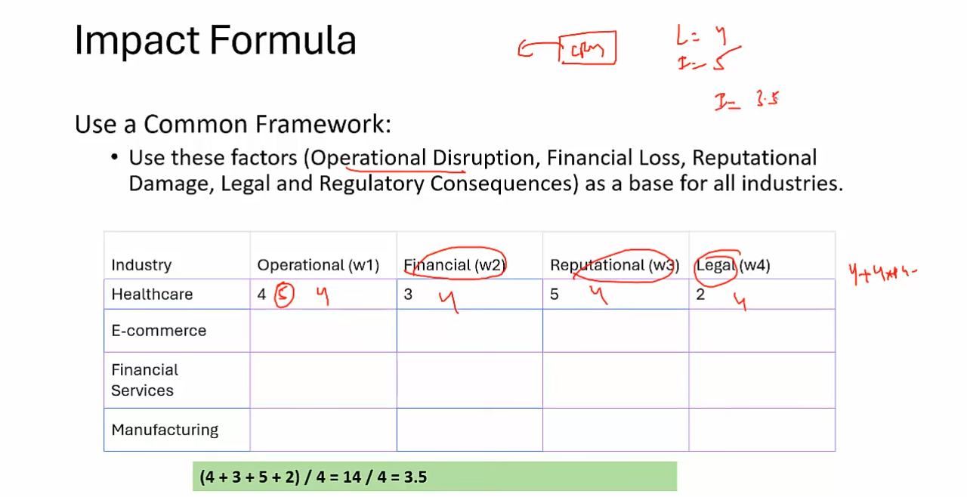

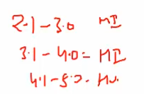moderate impact/ high impact ranges

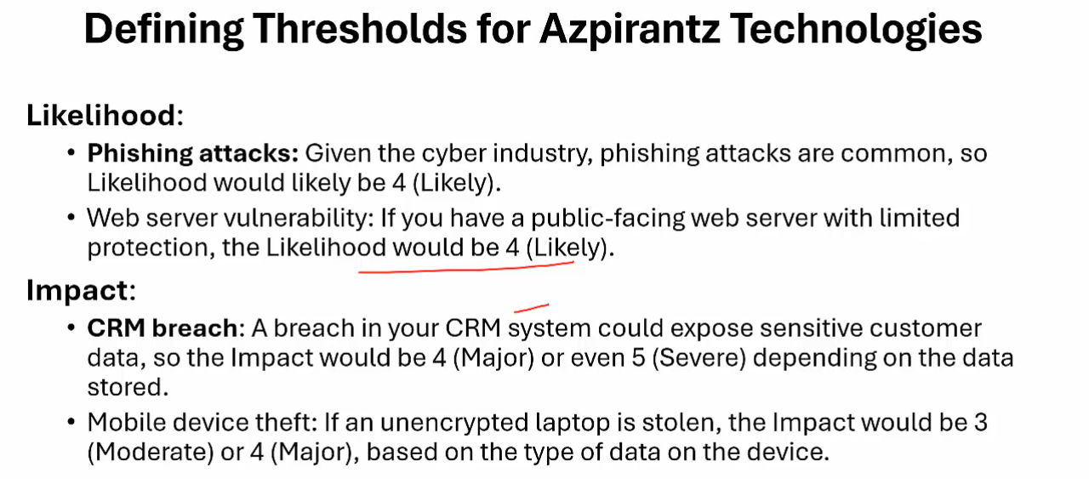

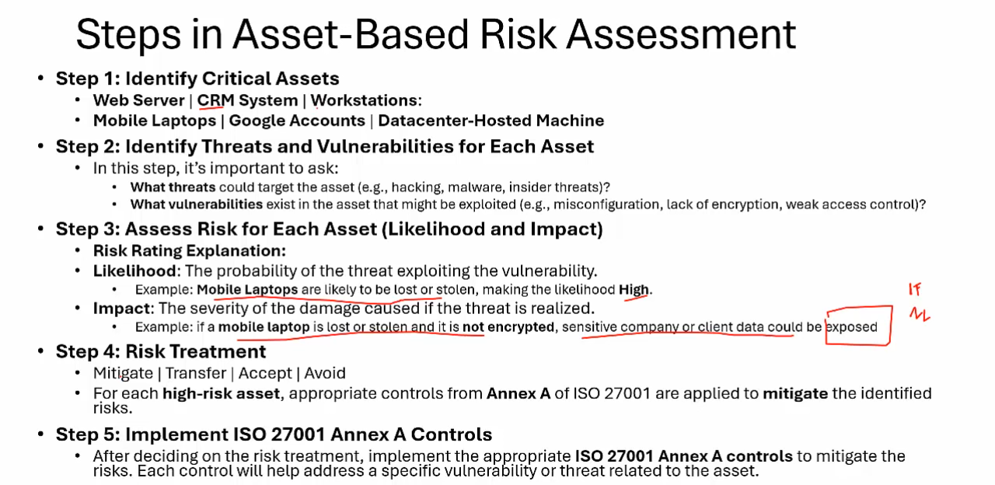

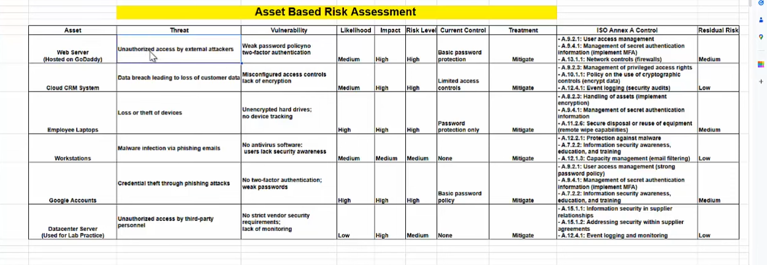

At [37:28](https://youtu.be/EAgQ6u7ARIA?si=lhBEqEUY_KXvFNSM&t=2248)

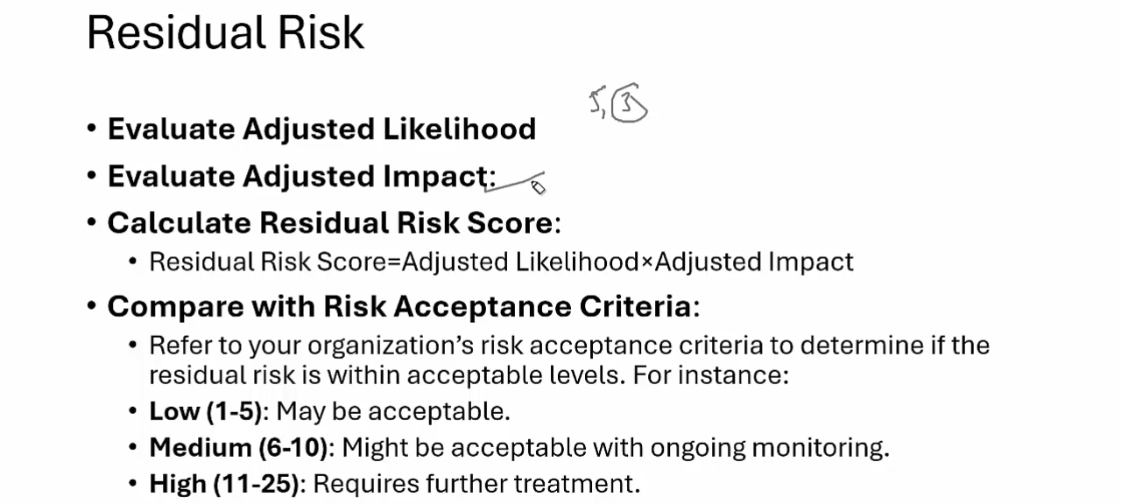

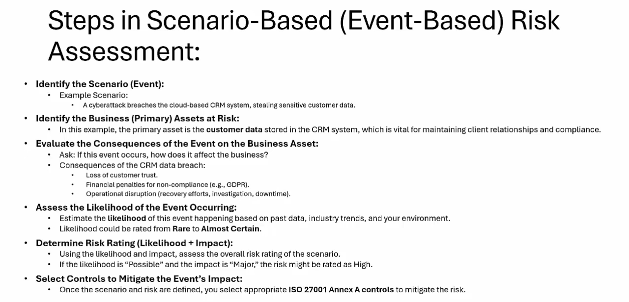

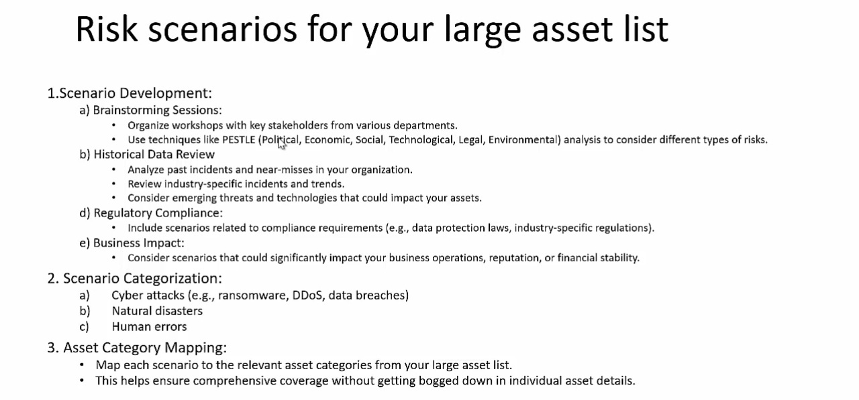

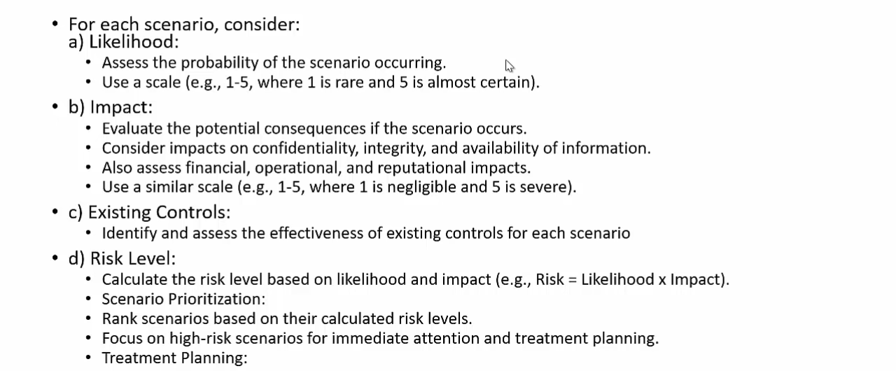

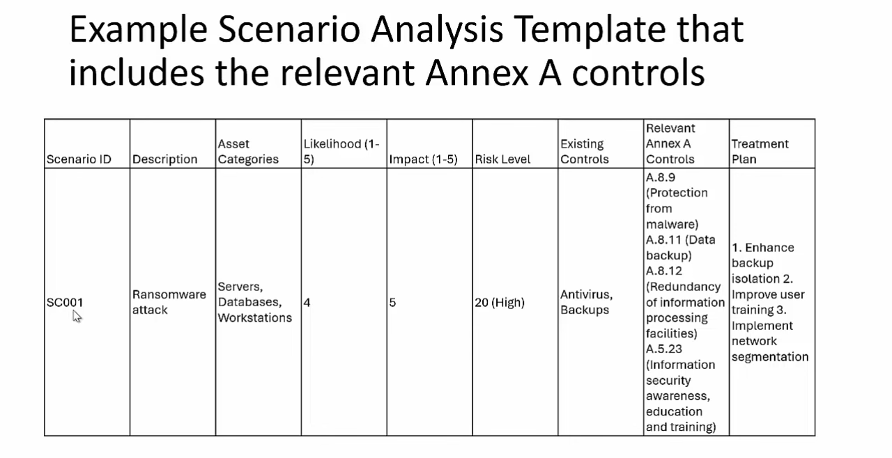

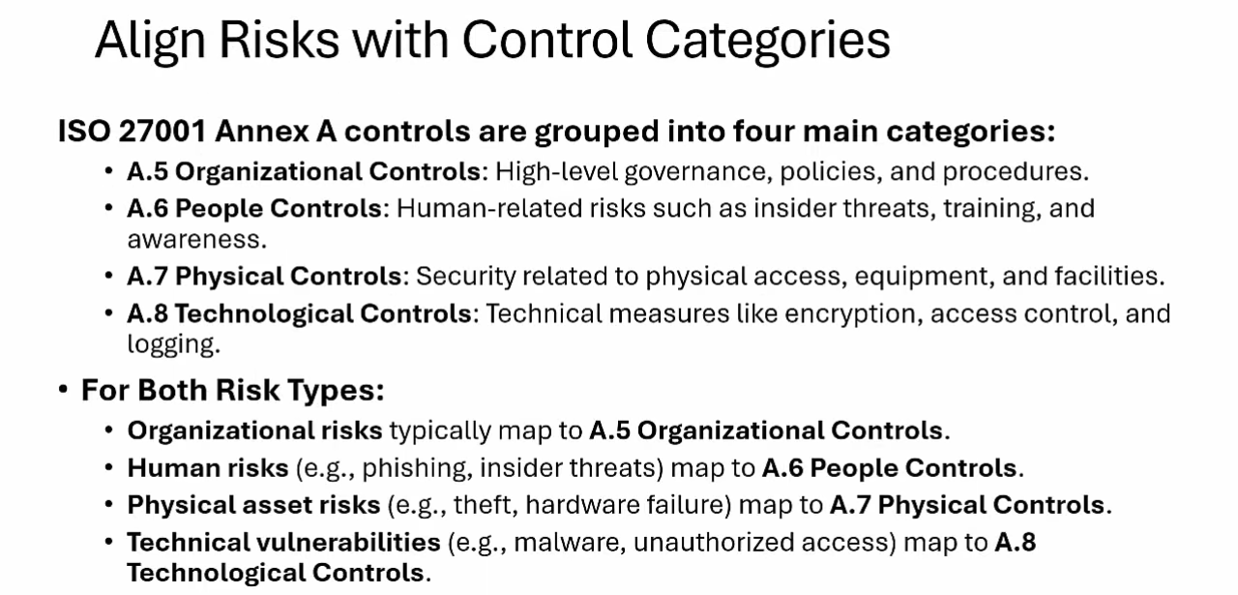

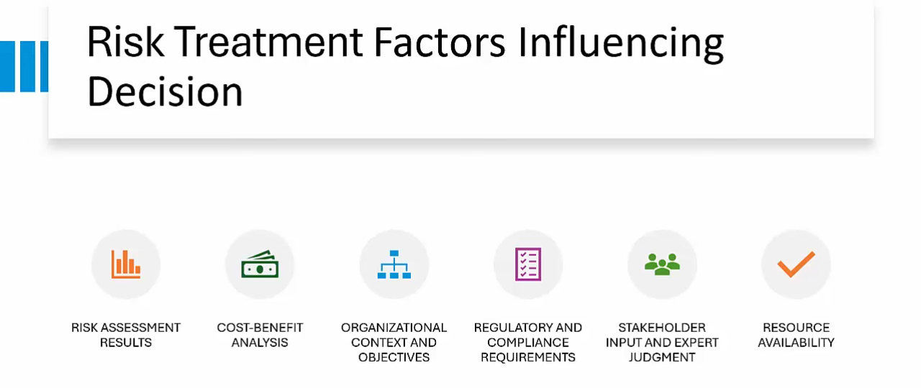

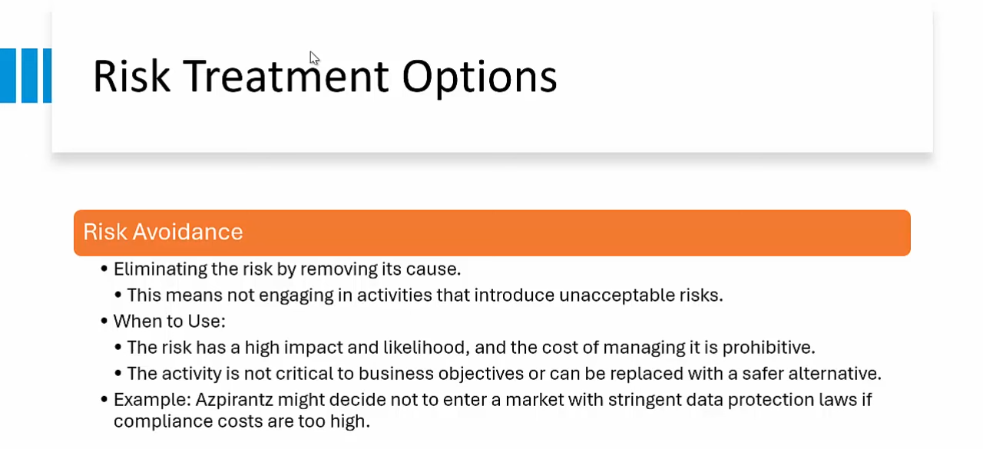

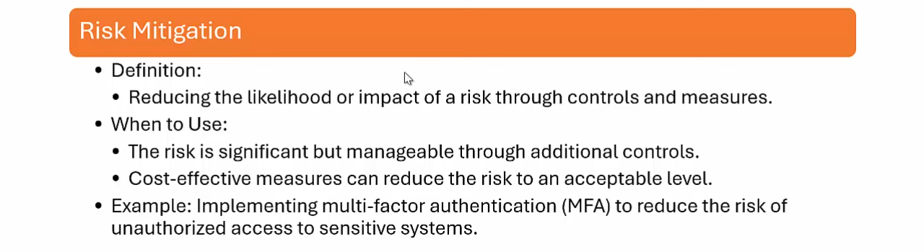

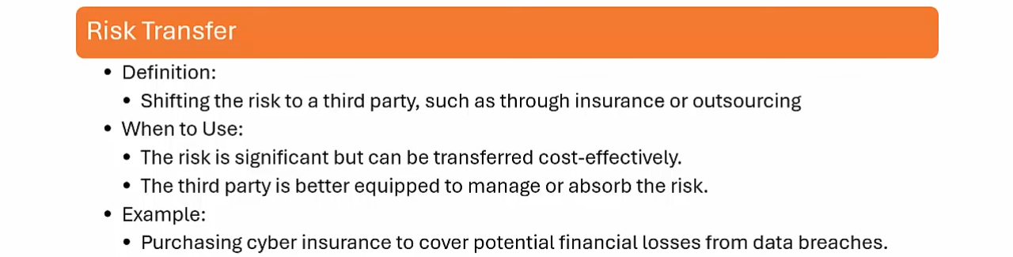

We do risk transfer when low likelihood but high impact. Health insurance and hospitalization example.

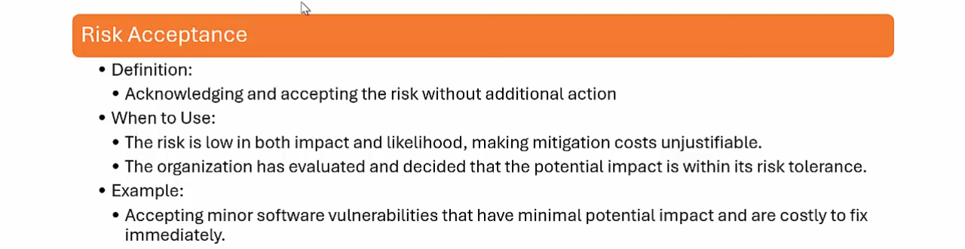

Template for risk management charter and risk management report starts at [52:04](https://youtu.be/EAgQ6u7ARIA?si=A6Tog9_15FCT5Esk&t=3124)

# Build a SoA (System of Applicability)

It`s all about implementing controls, some are controls made by risk other could be due to non-risk controls means not for risk assessment but required by ISMS (other factors like Business Objective).

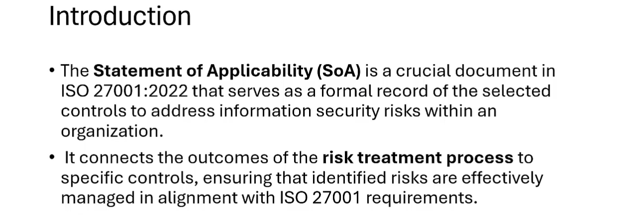

In ISO27001:2013 version there were 114 controls, now in ISO27001:2022 there are 93. Only implement applicable controls, and declare other as non-applicable. 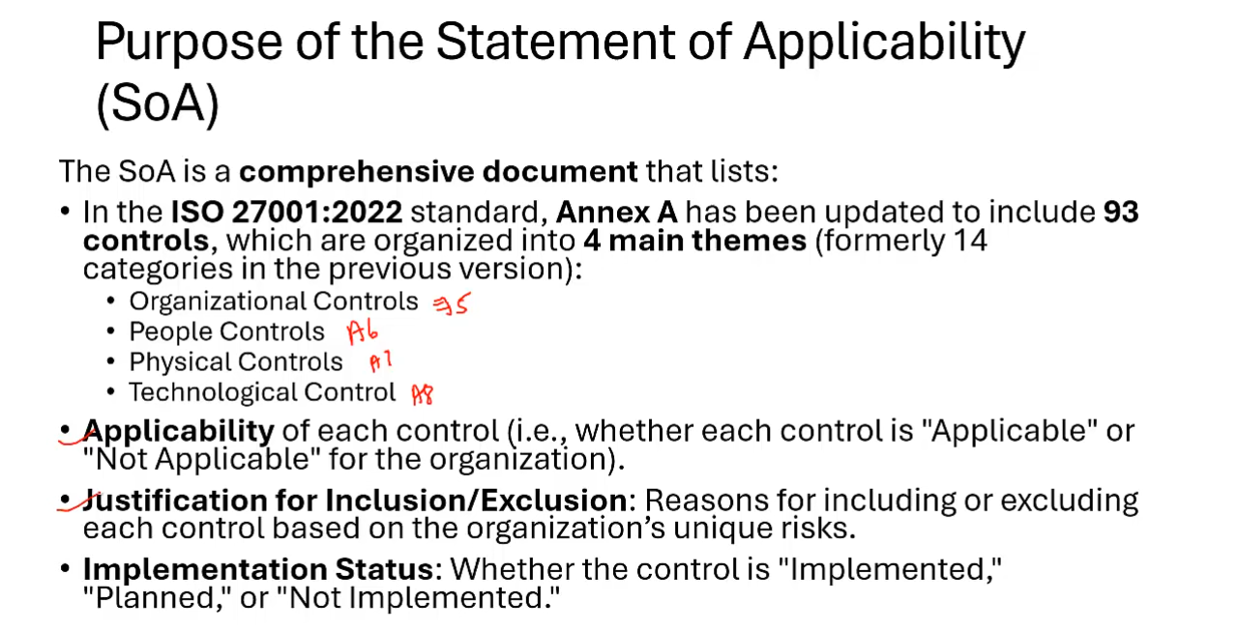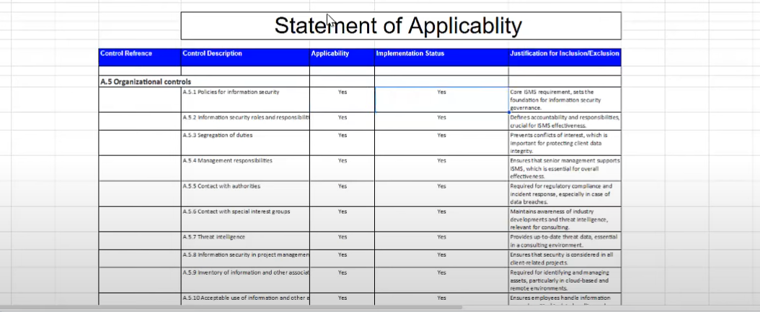

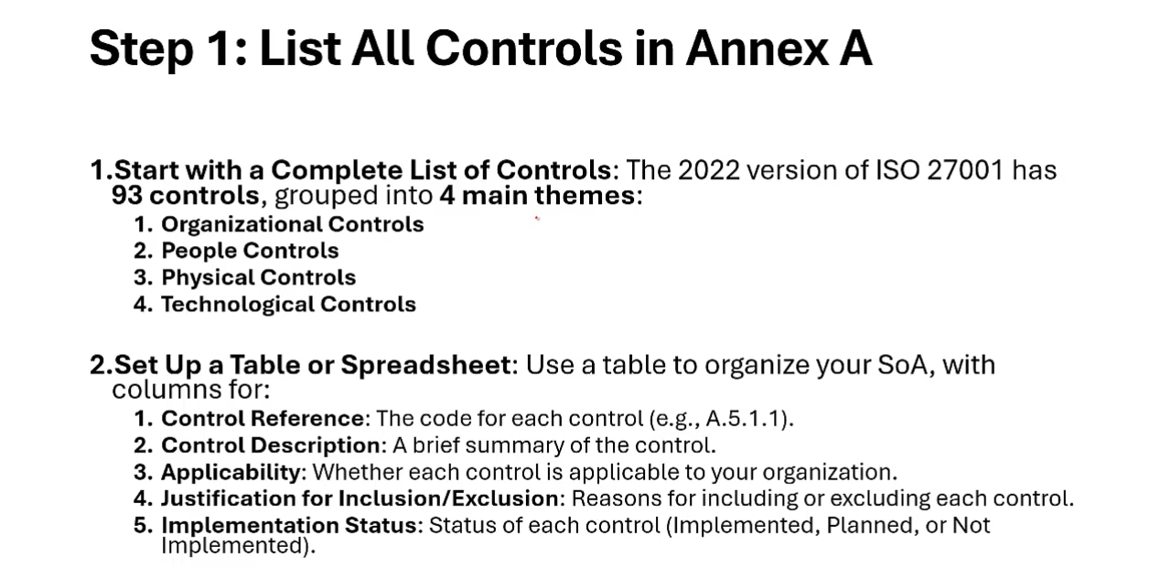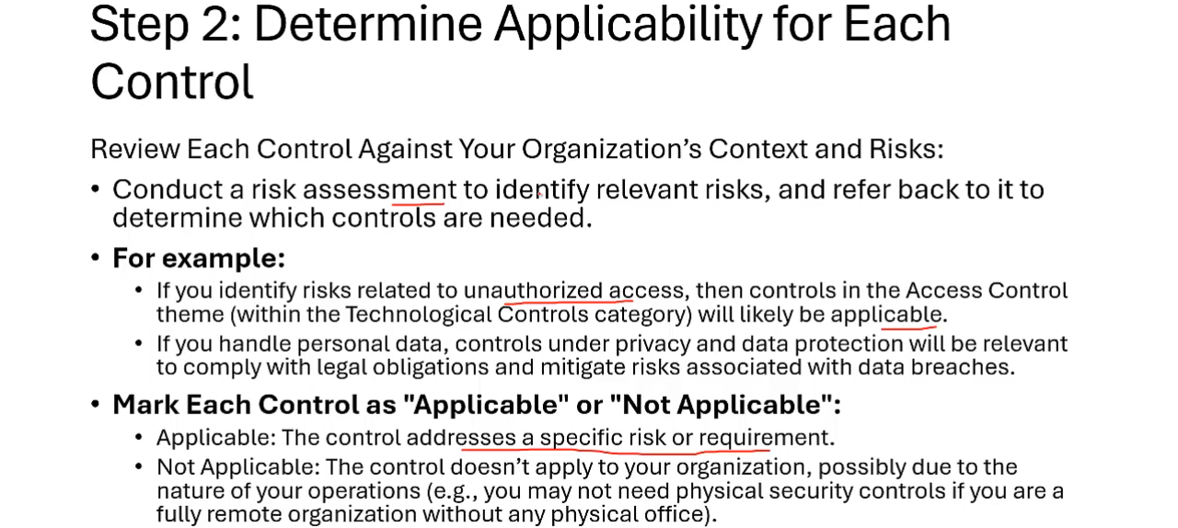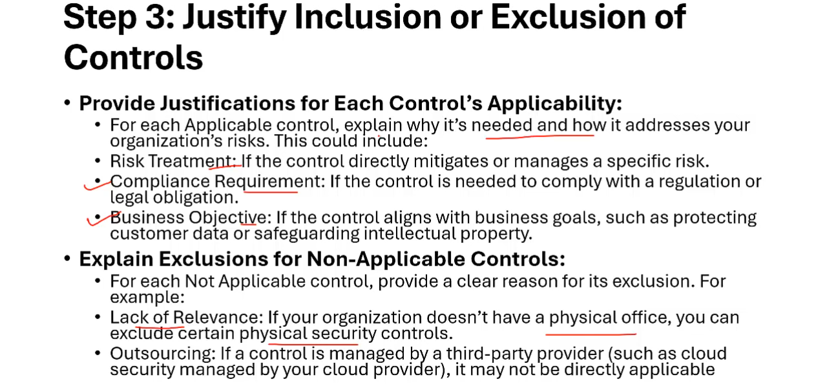

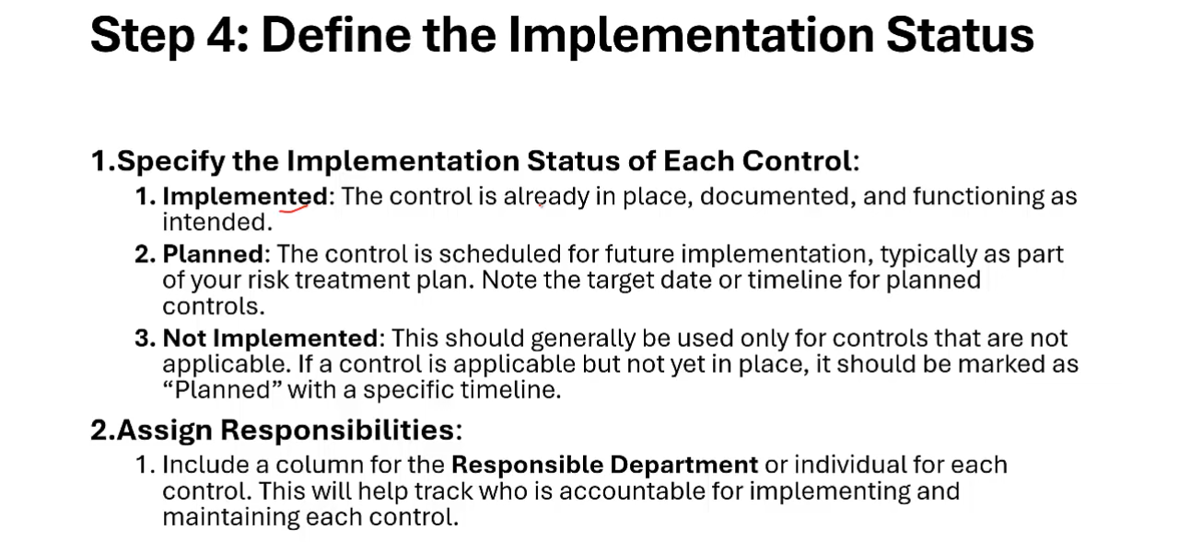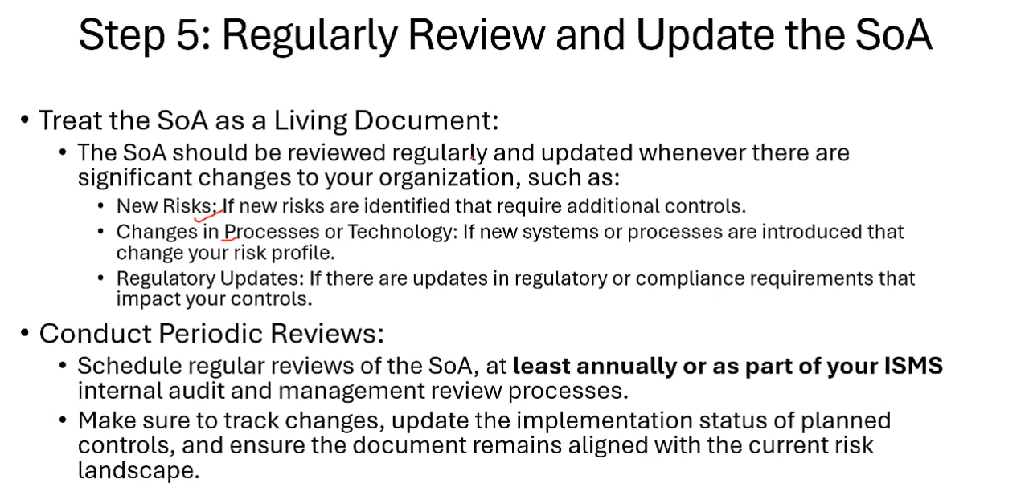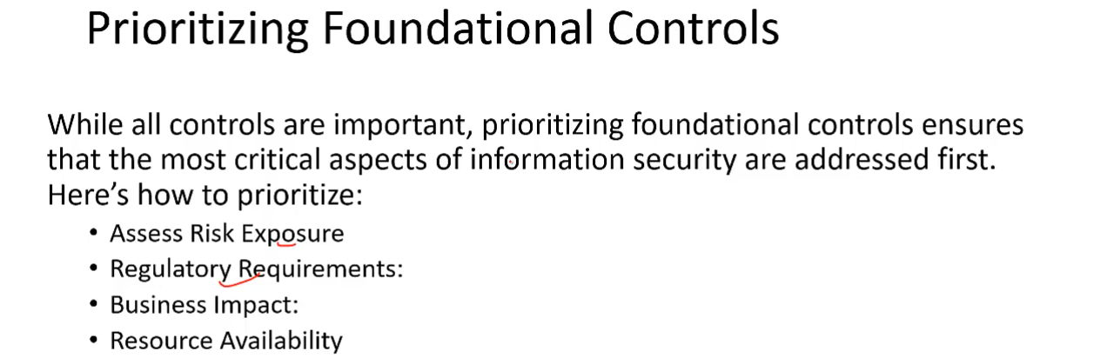

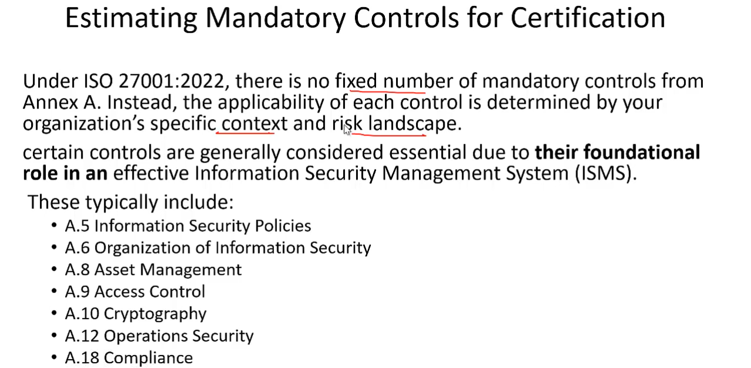

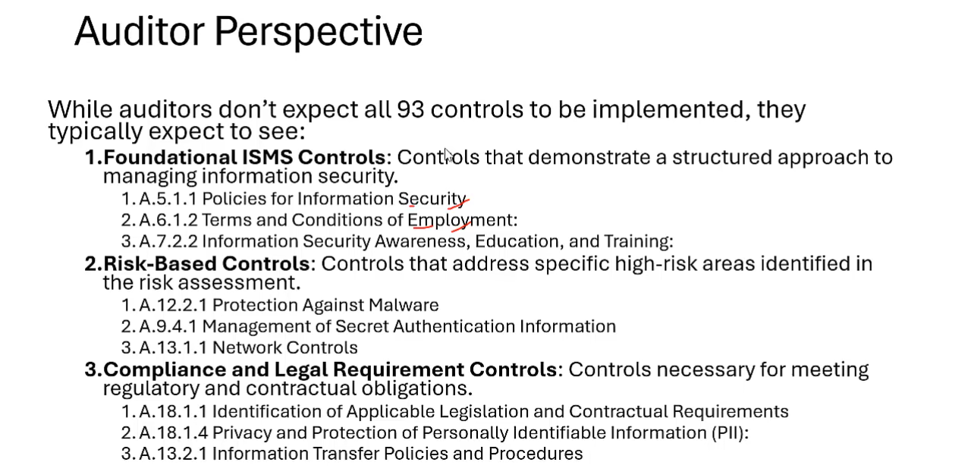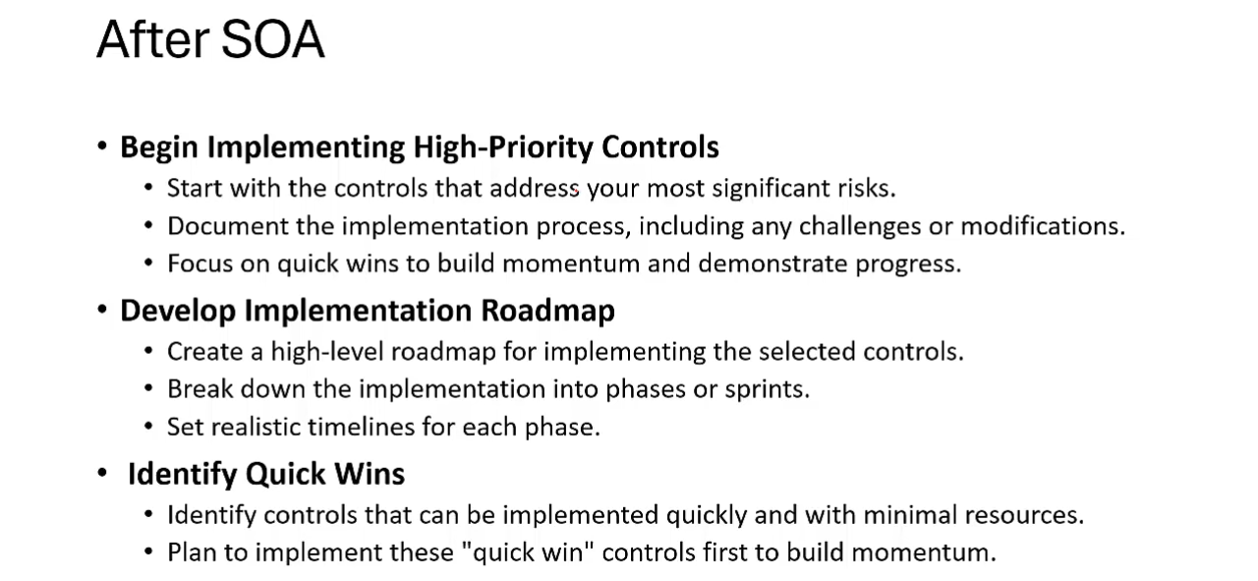

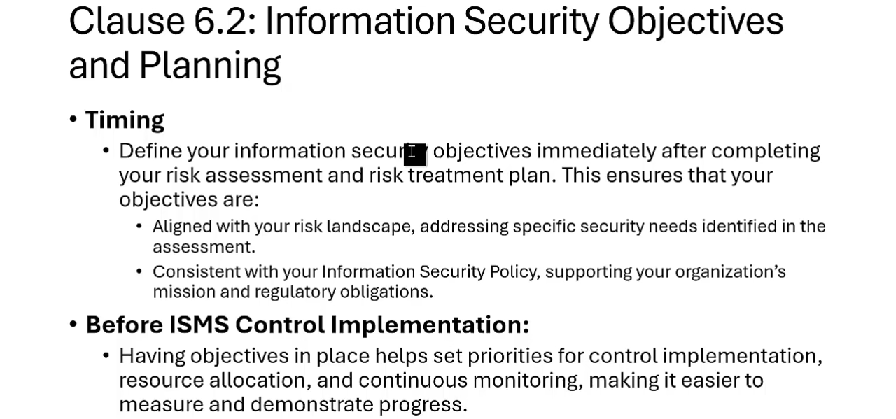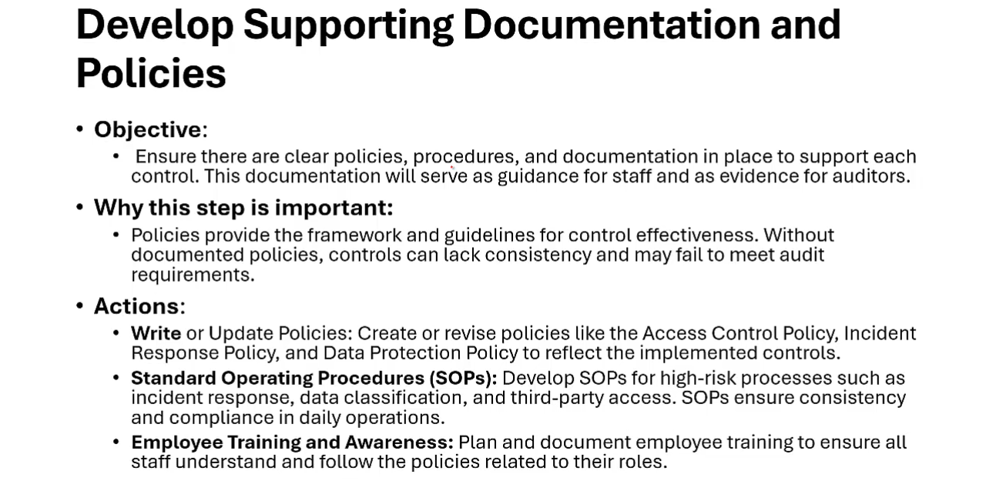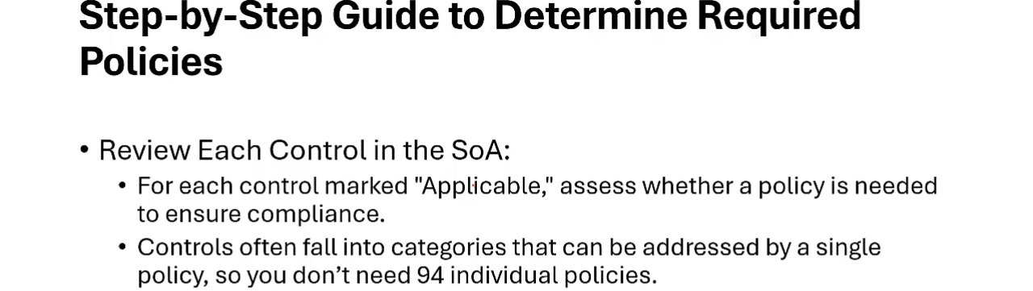

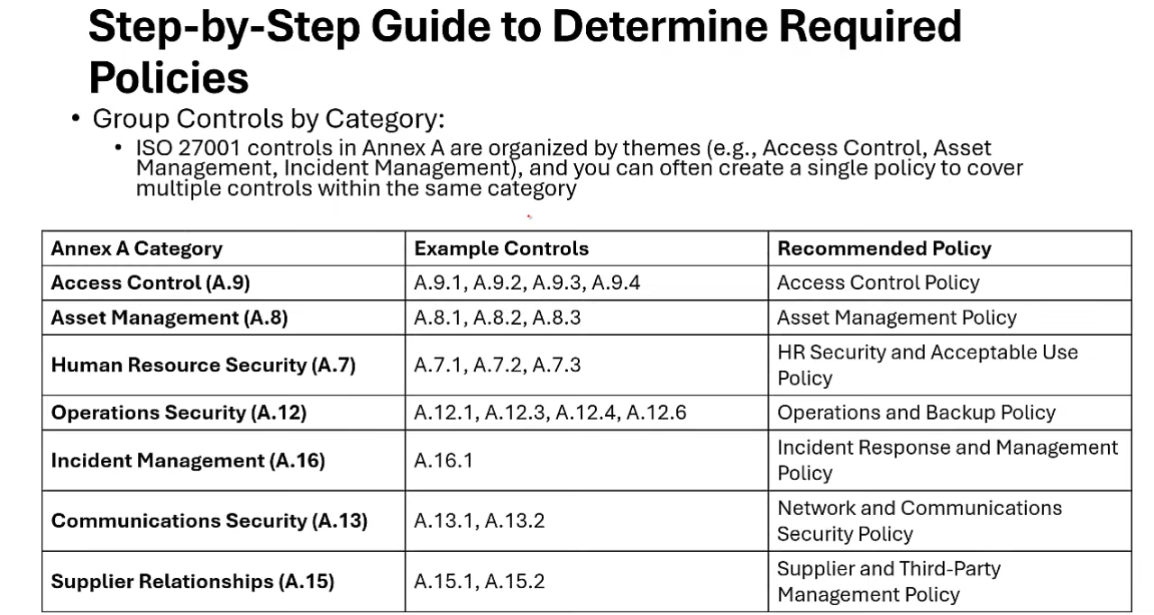

Multiple controls mapped to single policy

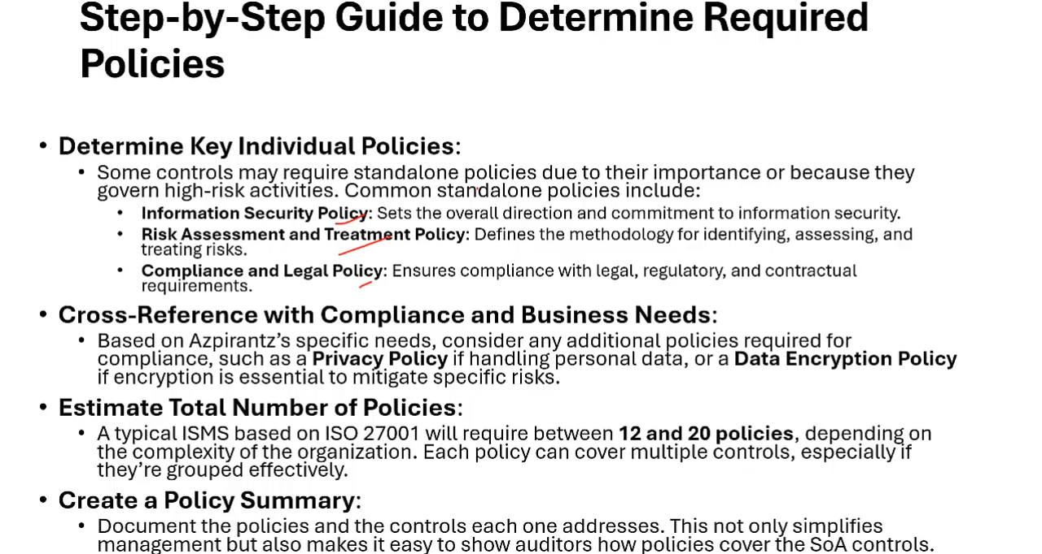

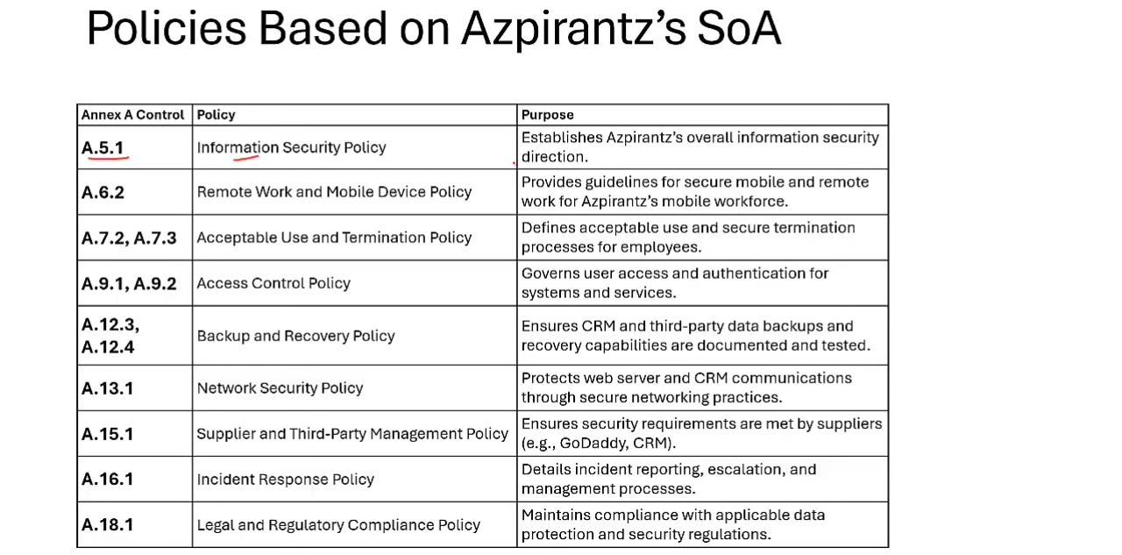

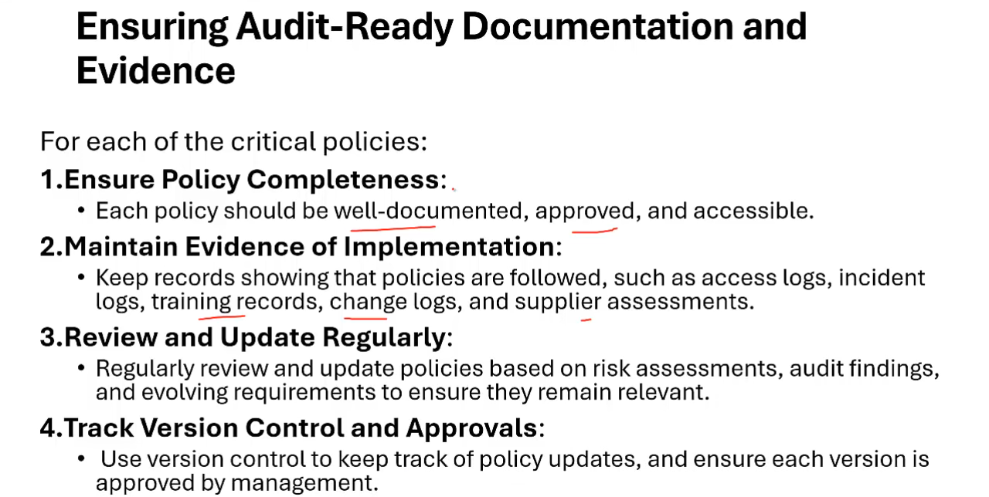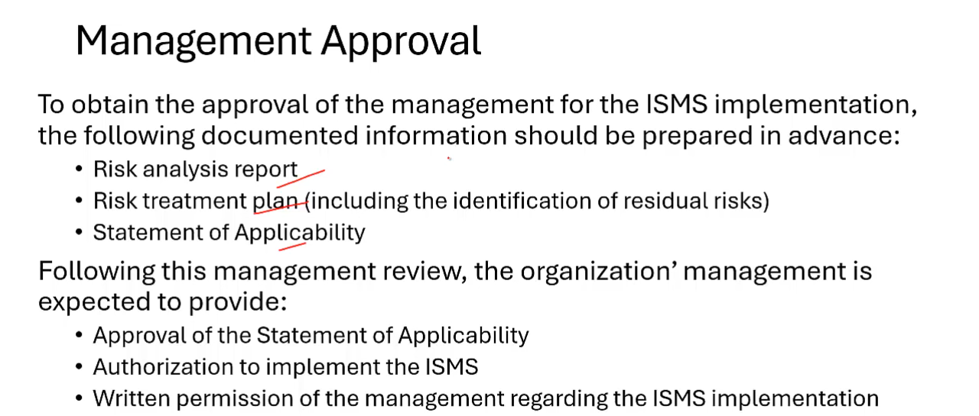

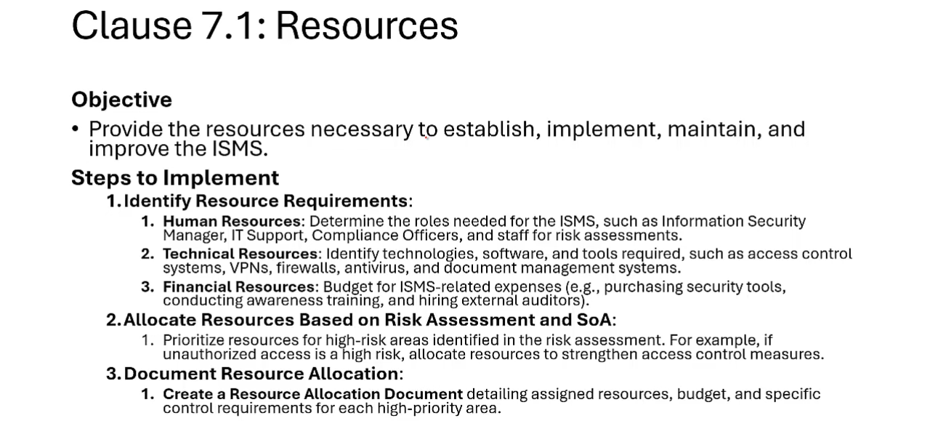

Apart from competency development report we also need competency development questionnaire, competency development procedures. 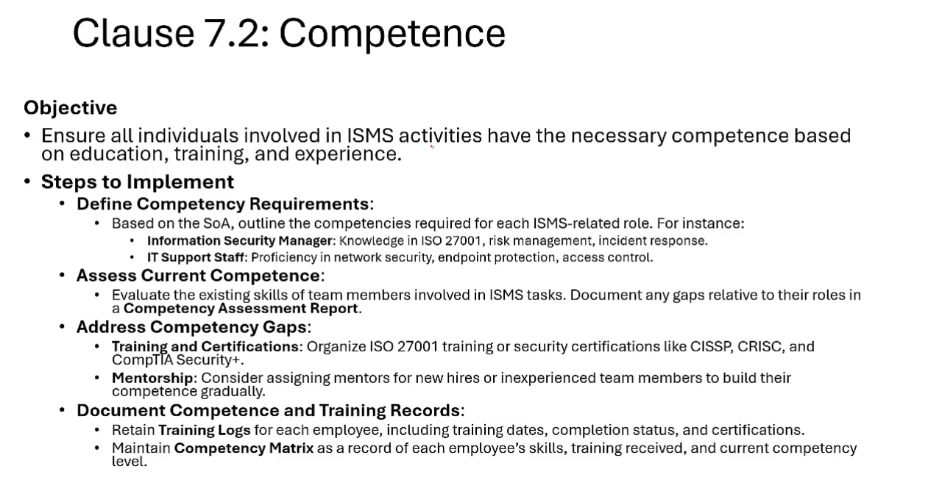 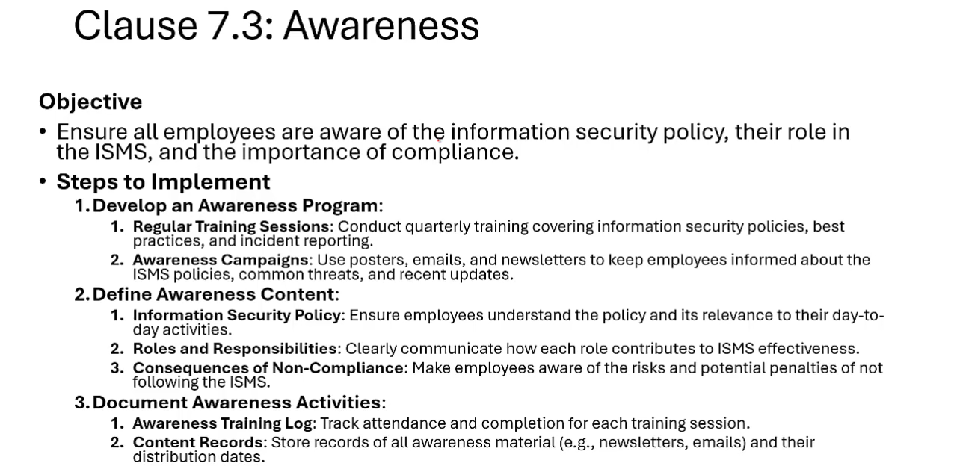

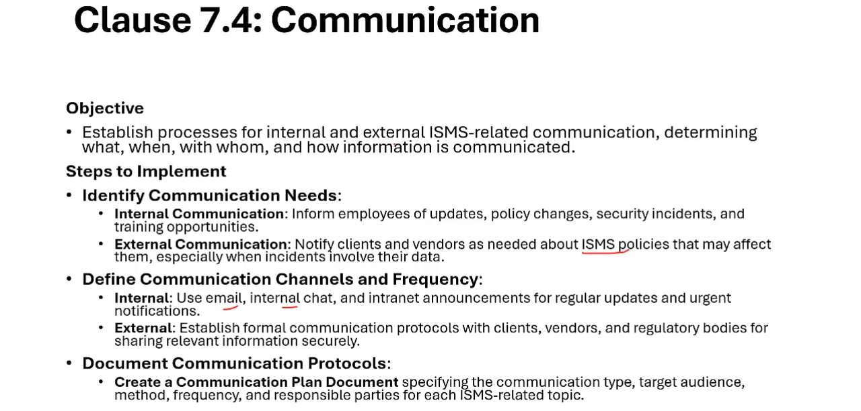

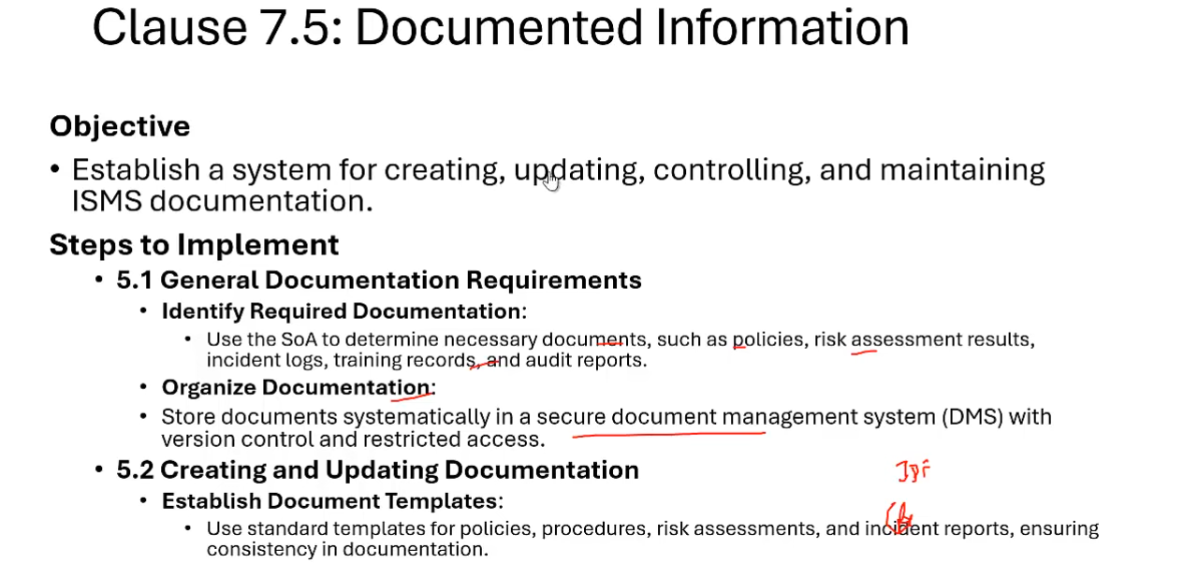 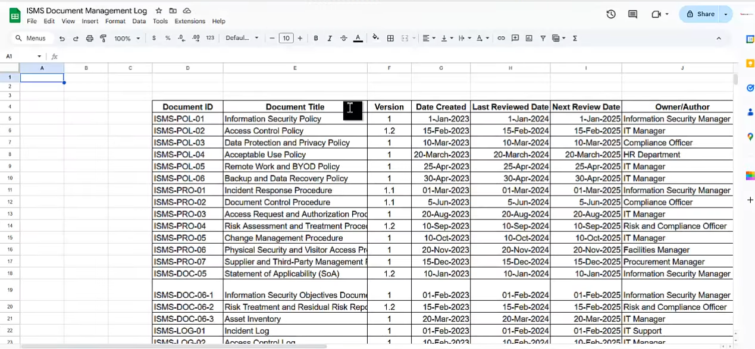

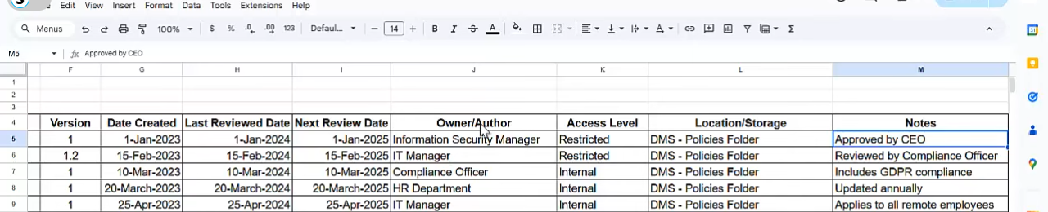

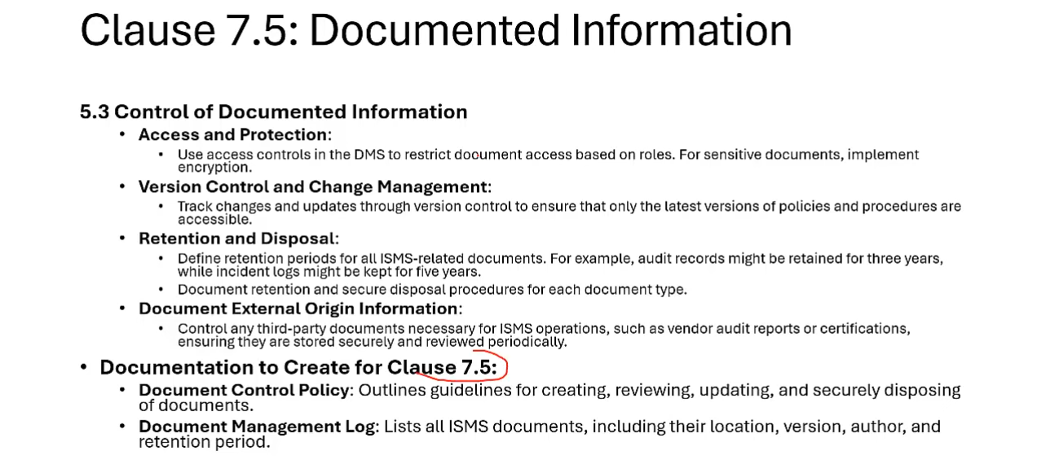 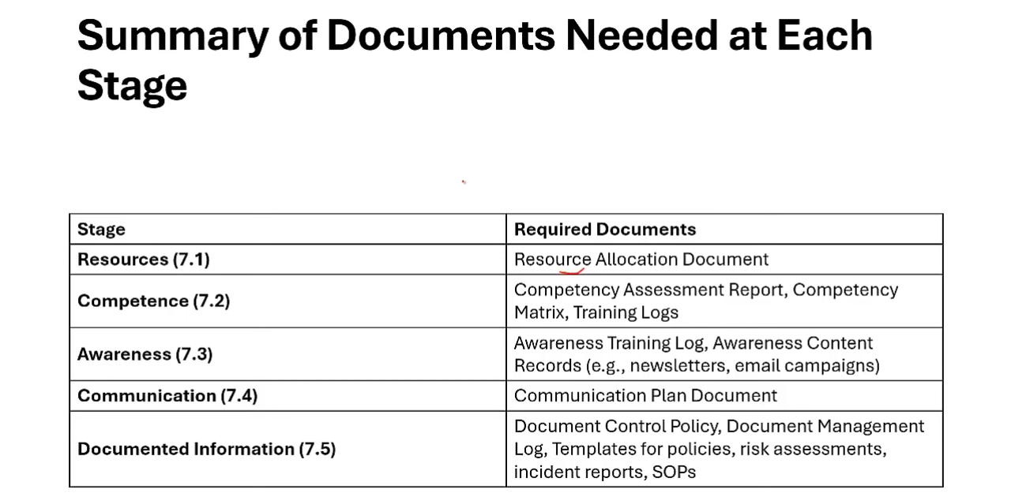

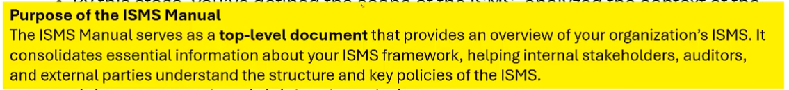

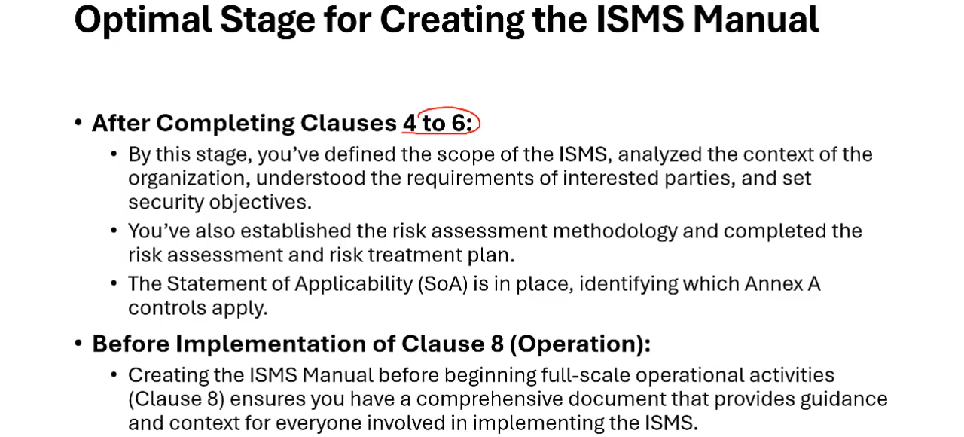

Scope nad context can be copied from context document. 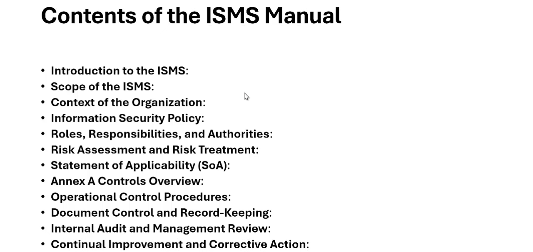

ISMS manual template at [36:42](https://youtu.be/S4nroRs2AFw?si=RErQ5Iw8cJDfdVcn&t=2202) 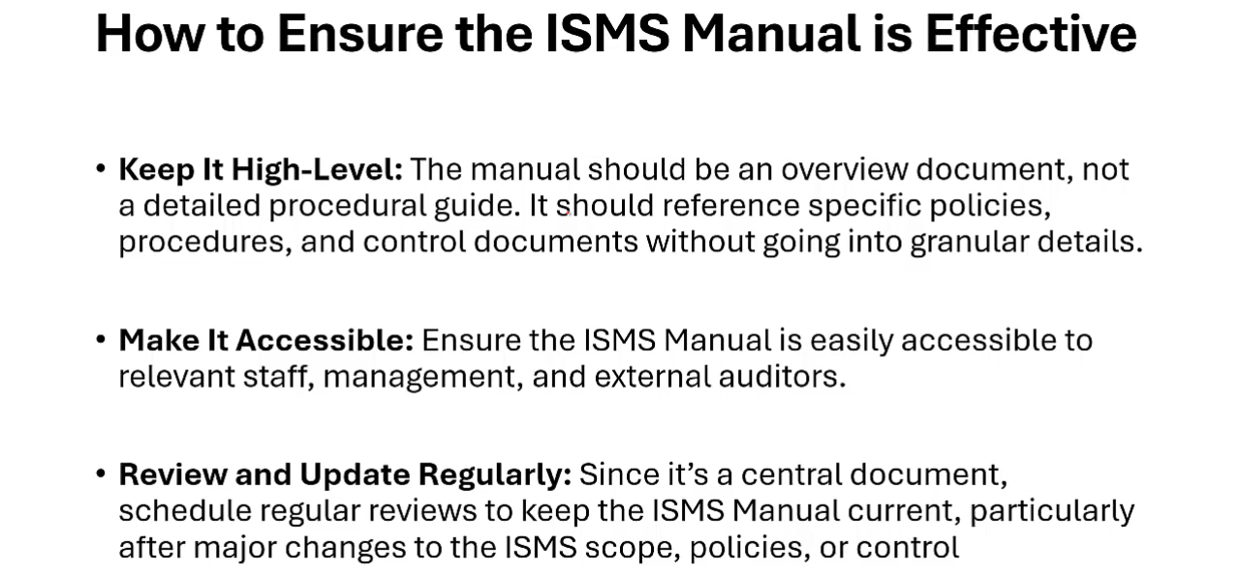

# CLAUSE 8,9,10:

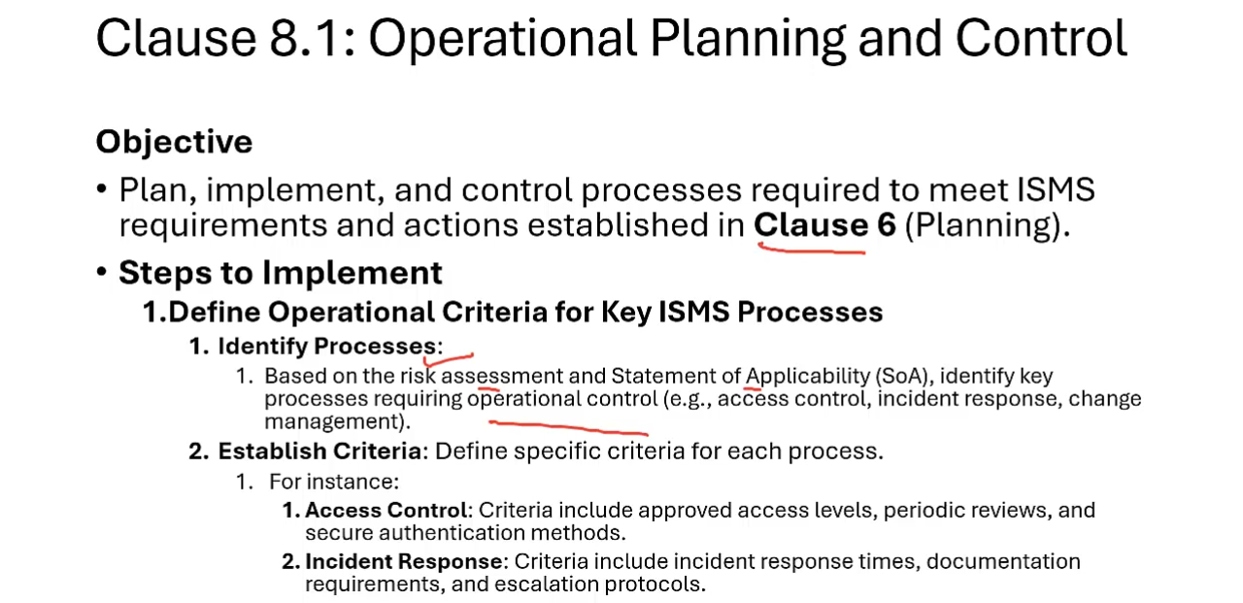

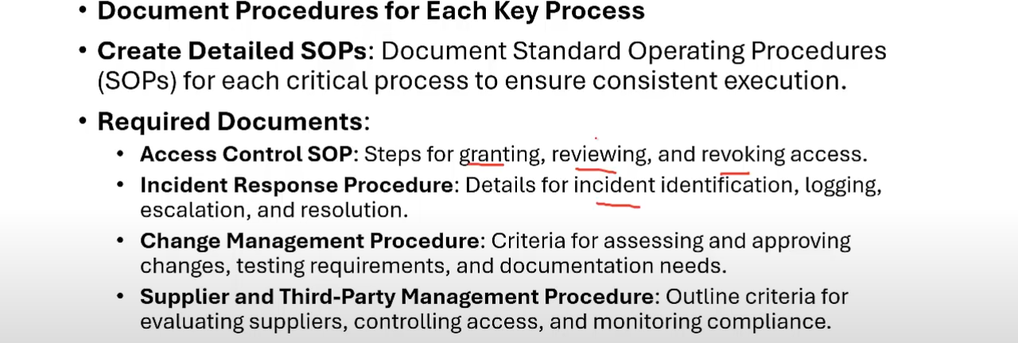

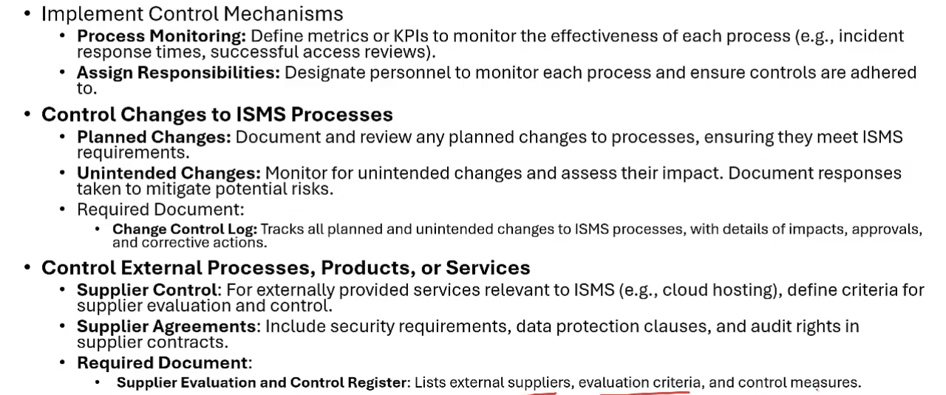

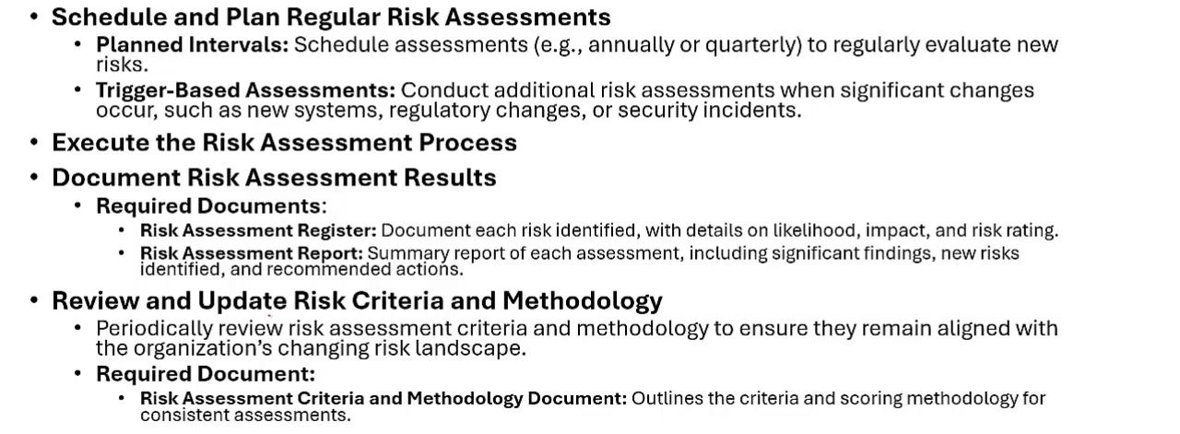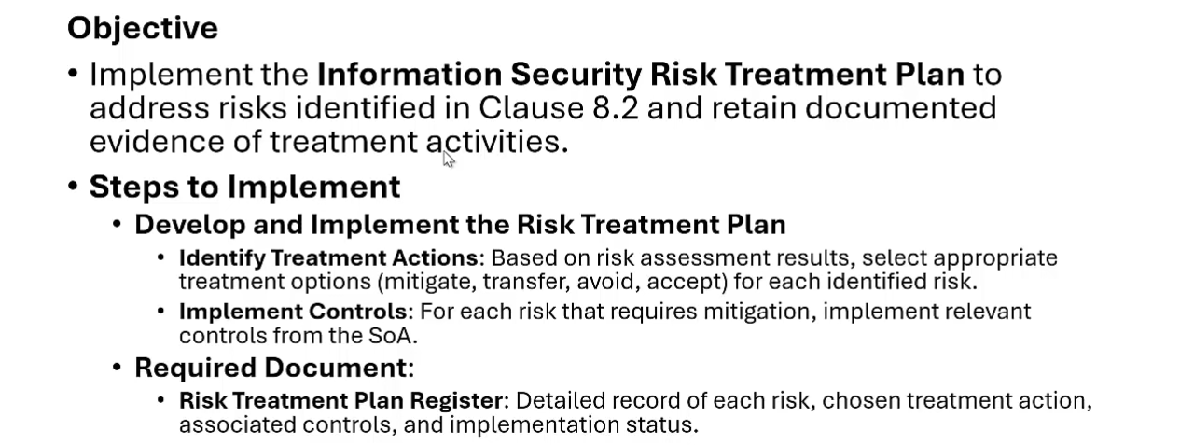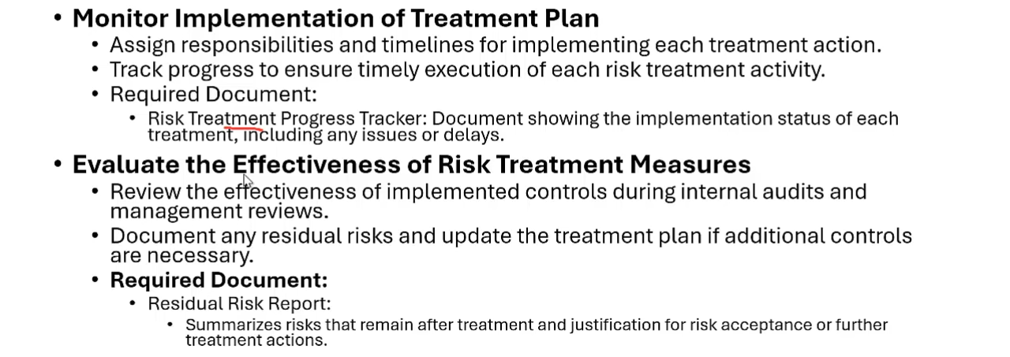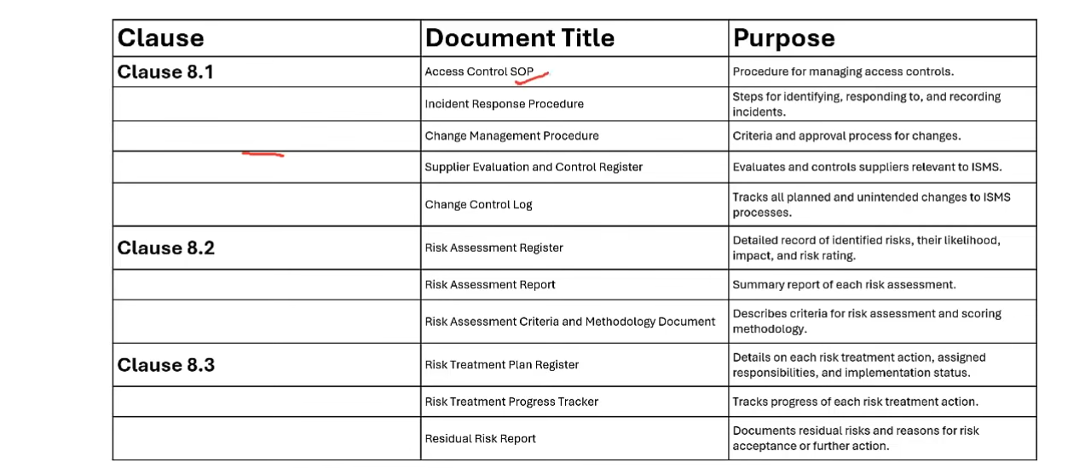

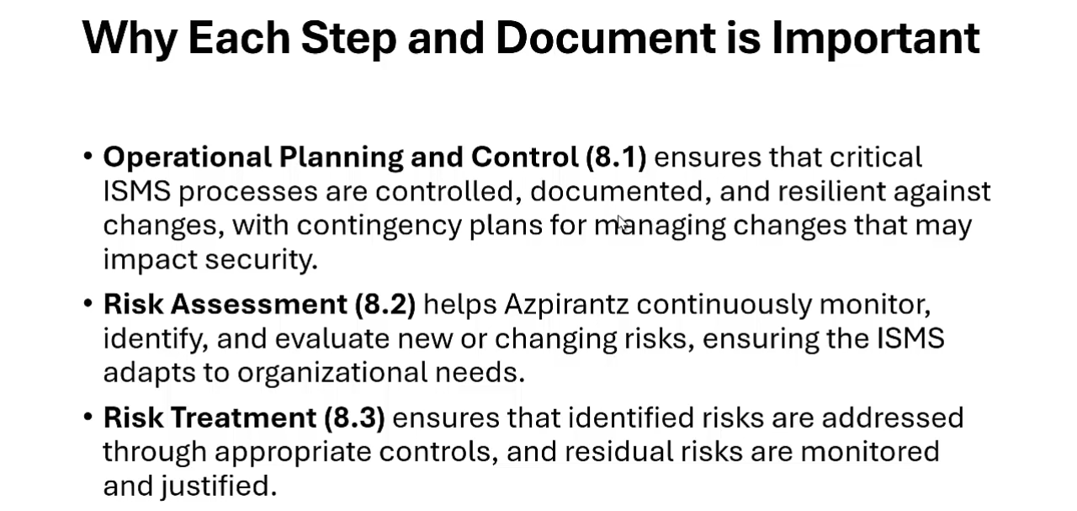

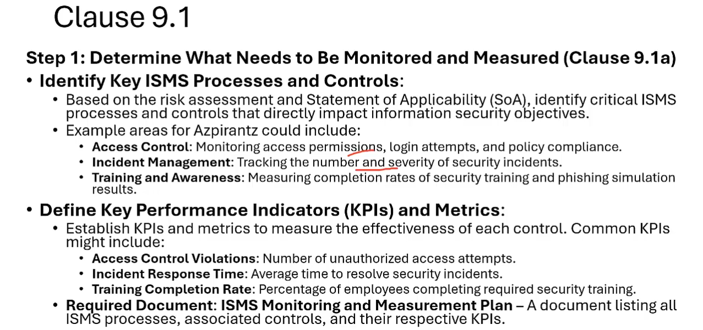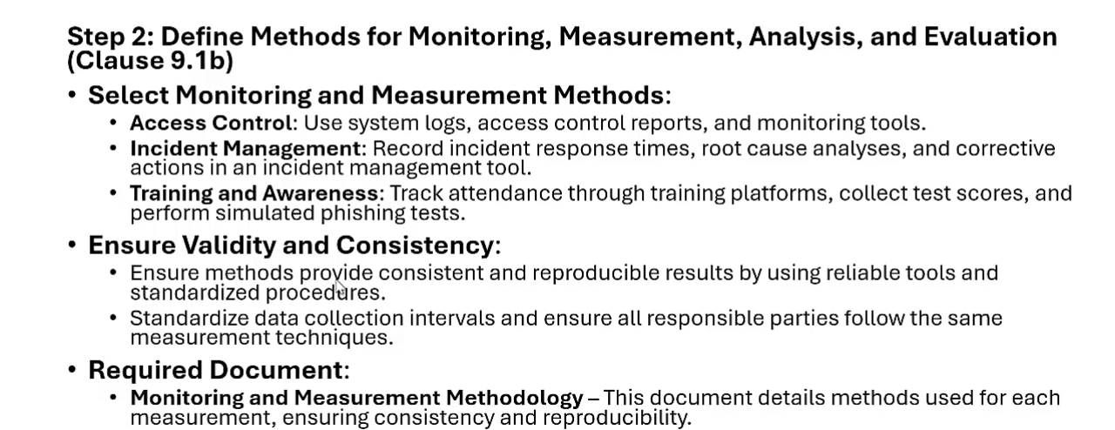

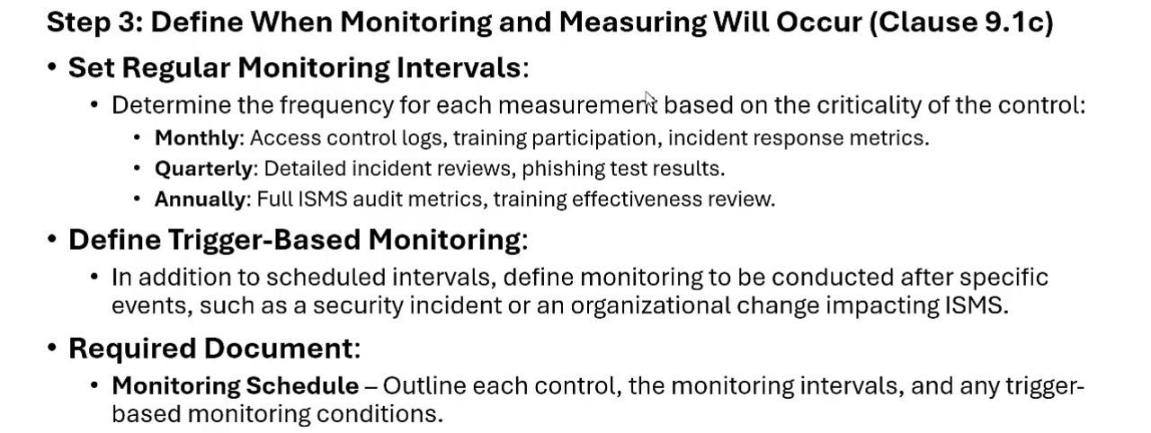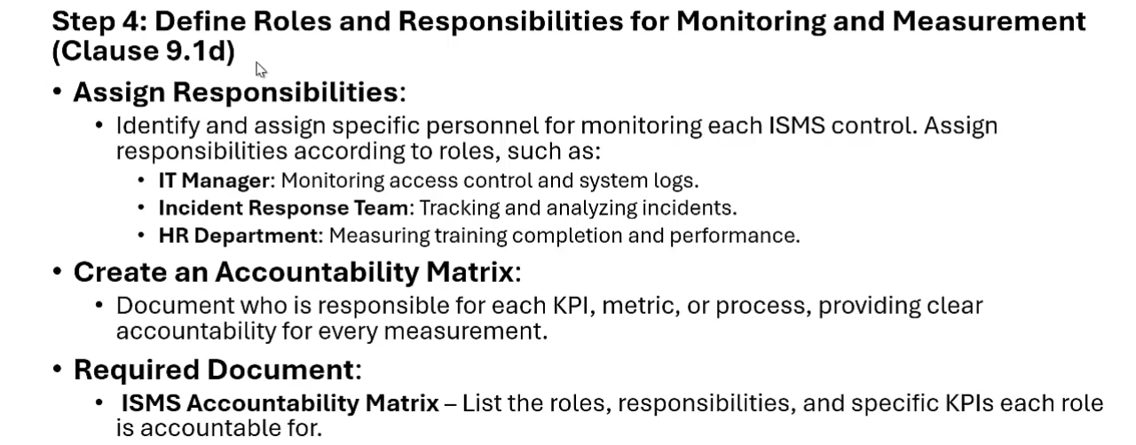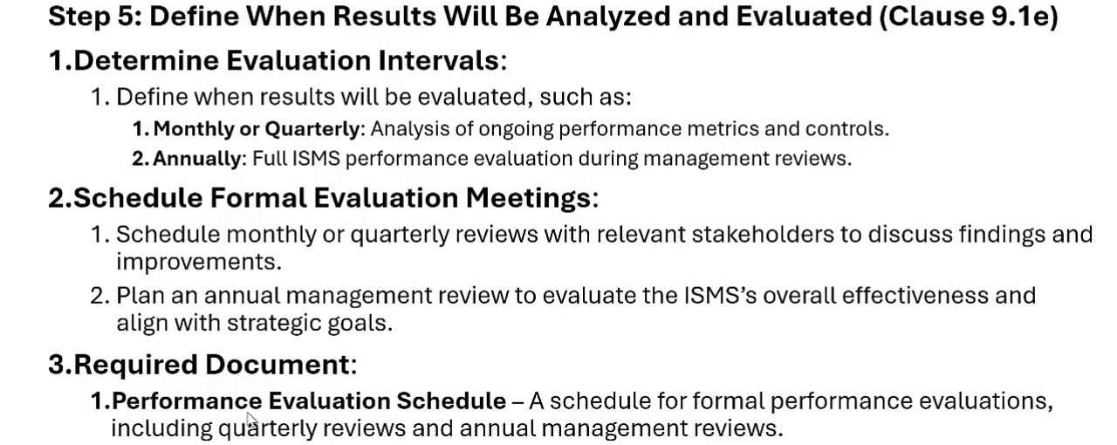

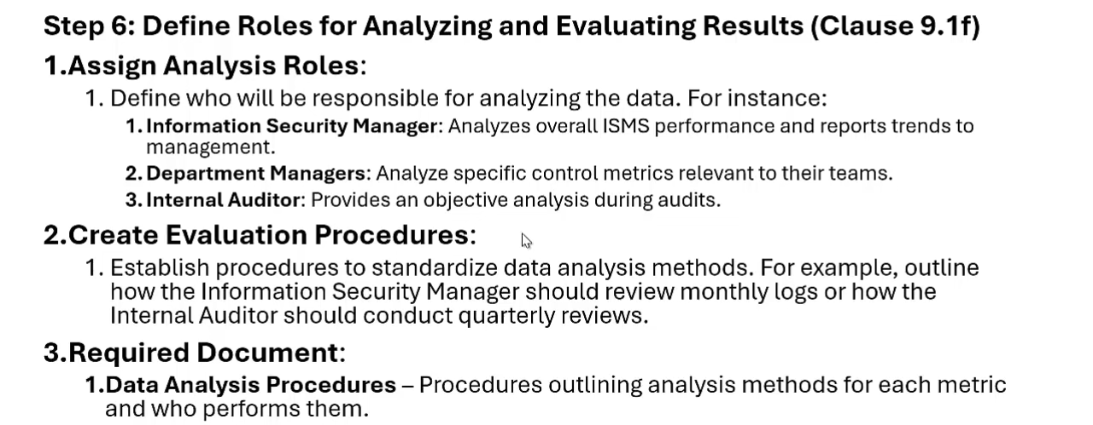

# 

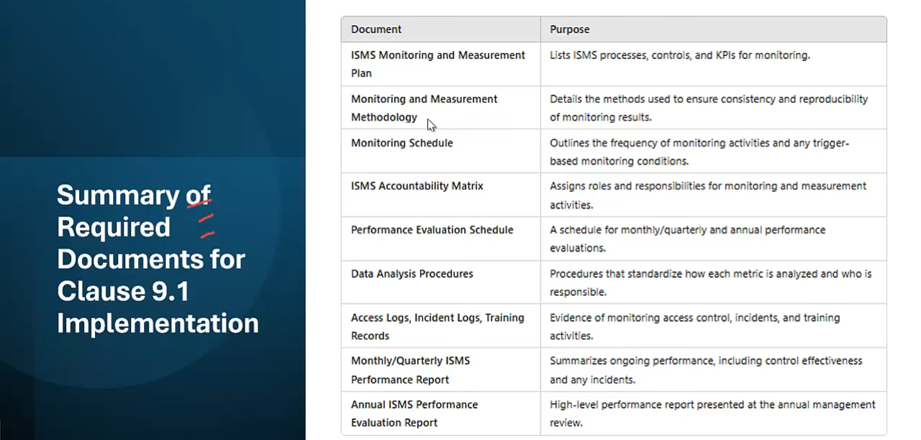

Internal audit: Organization within itself

External audit: organization from extrenal organization but not certification but for testing

Third-party audit: main audit to issue certificate

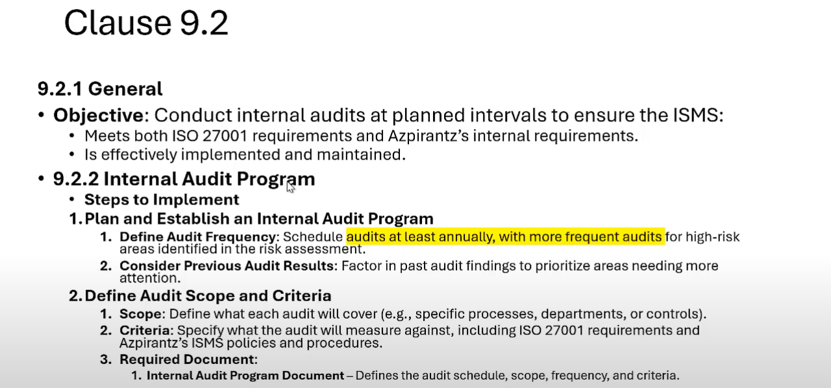

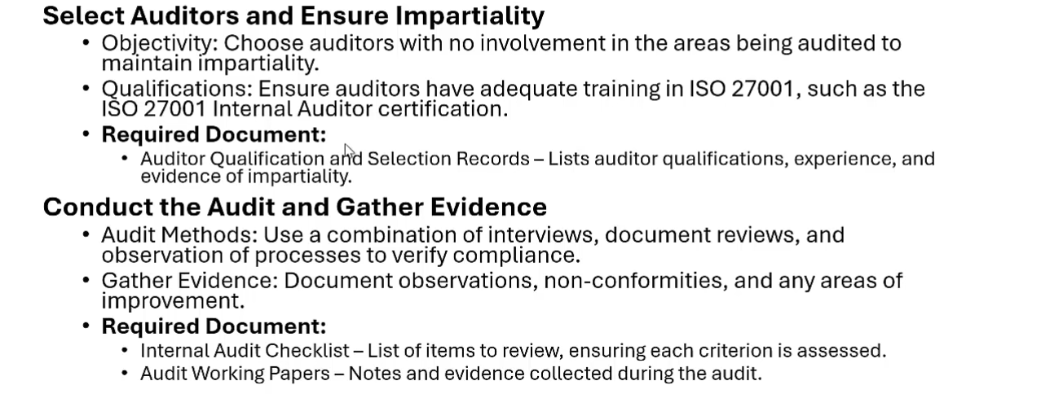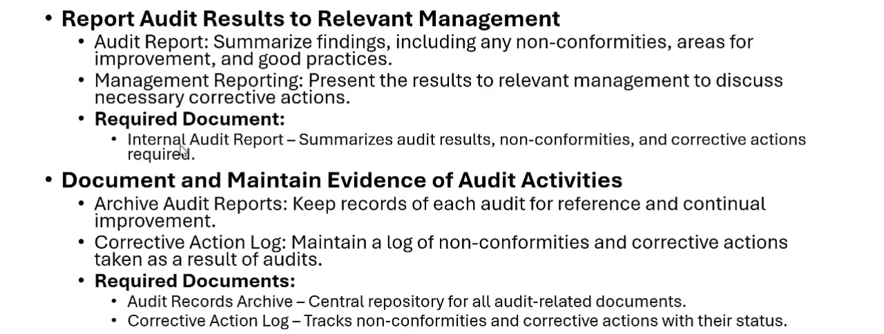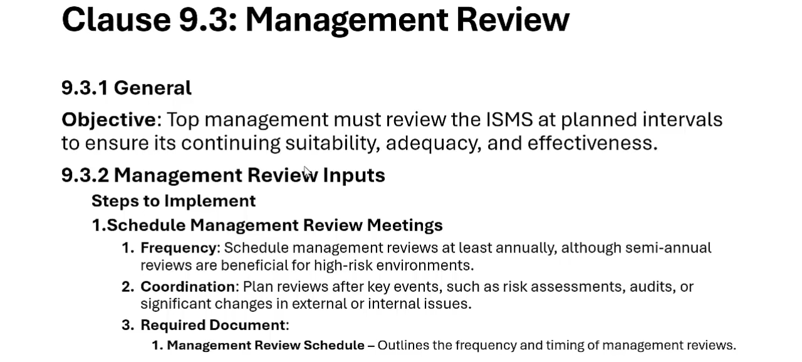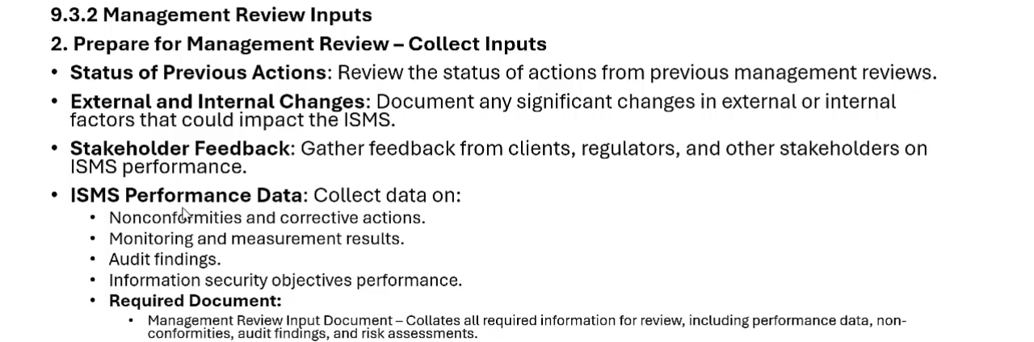

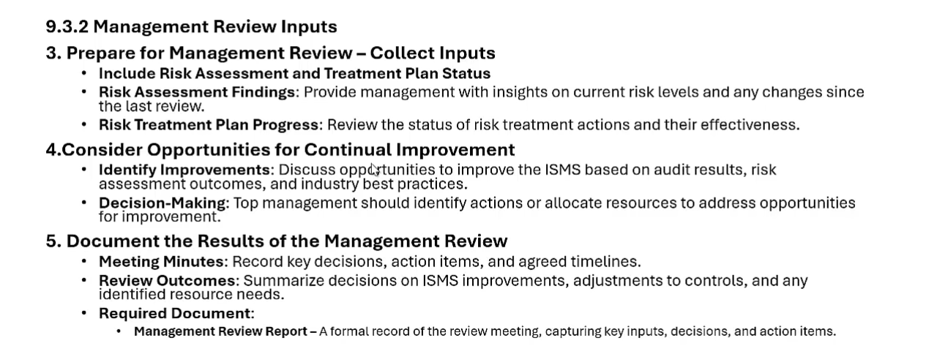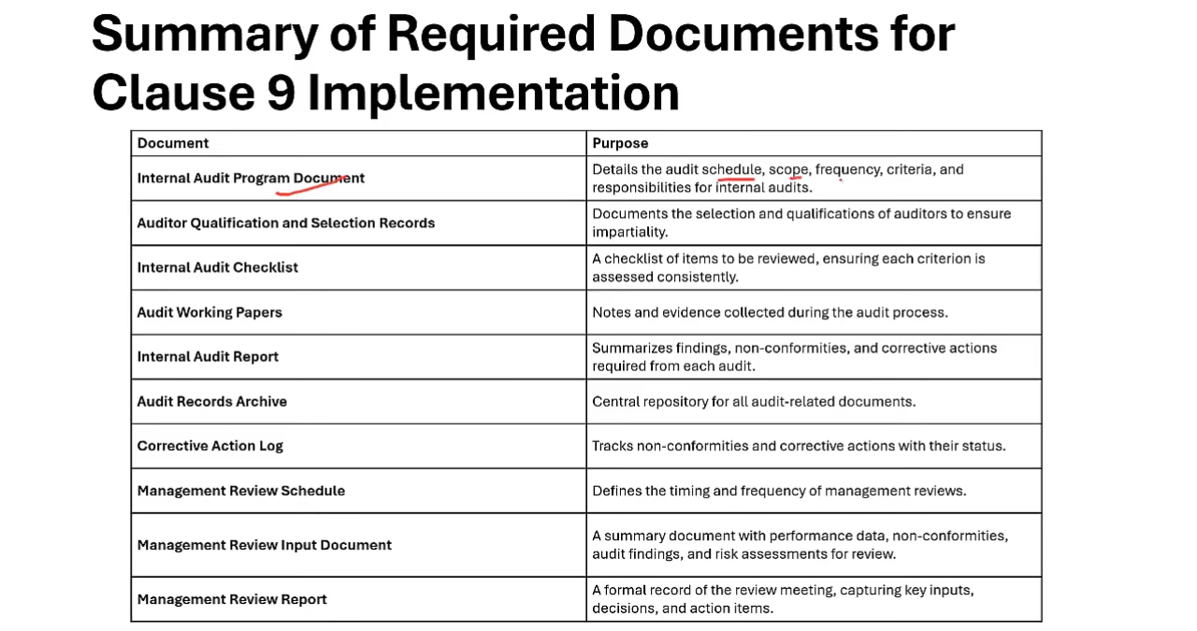

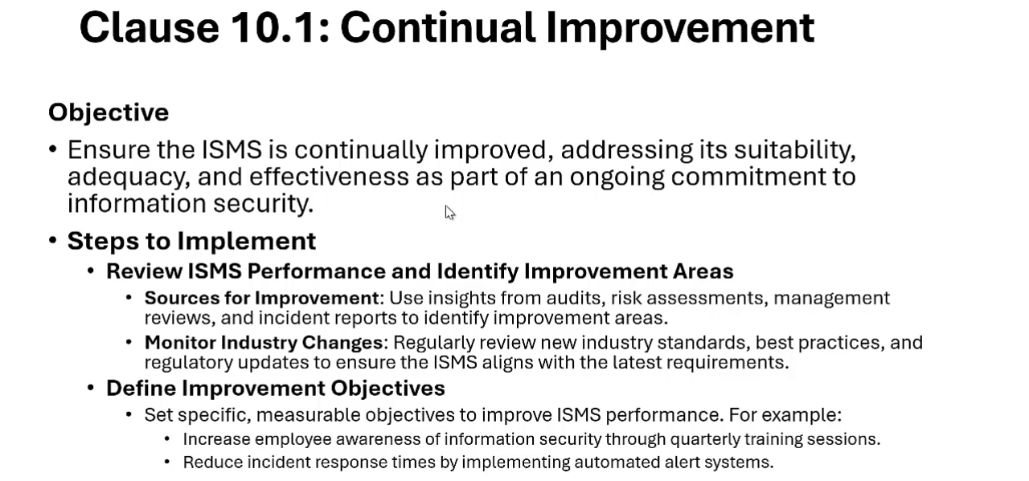

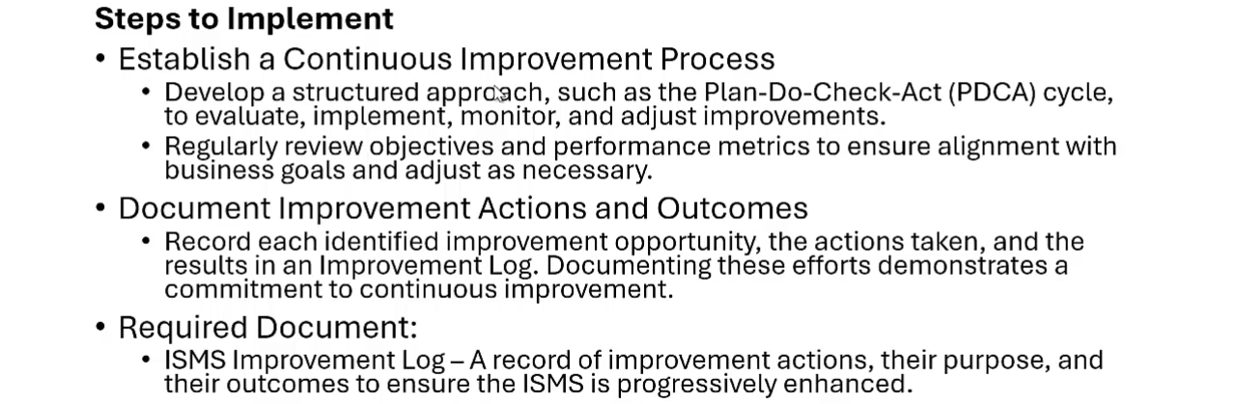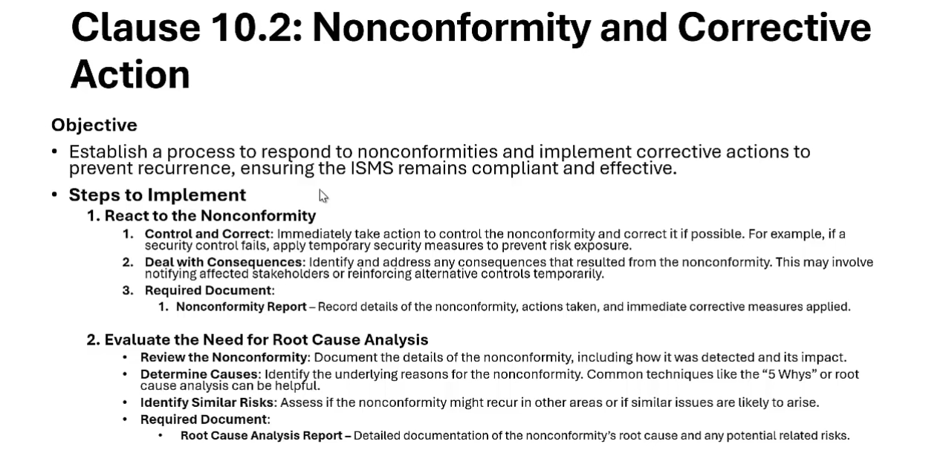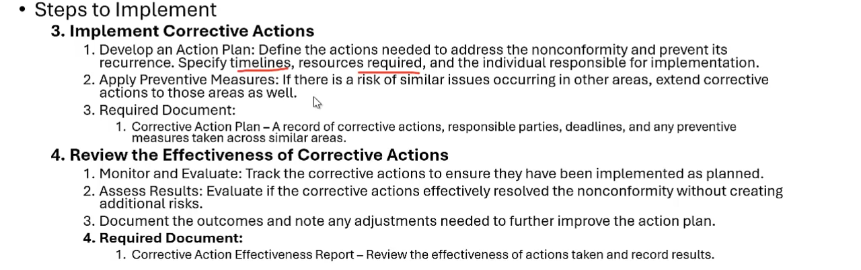

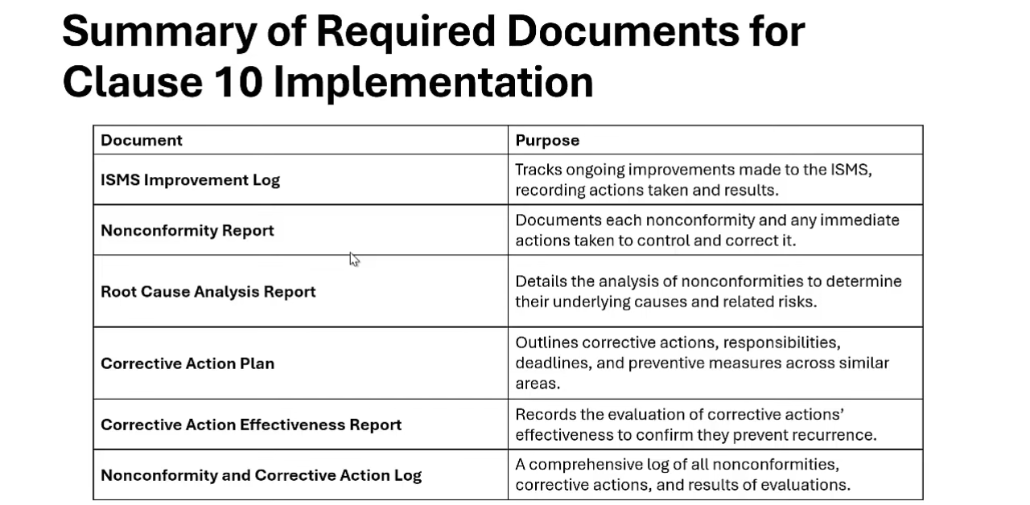

# FINAL

